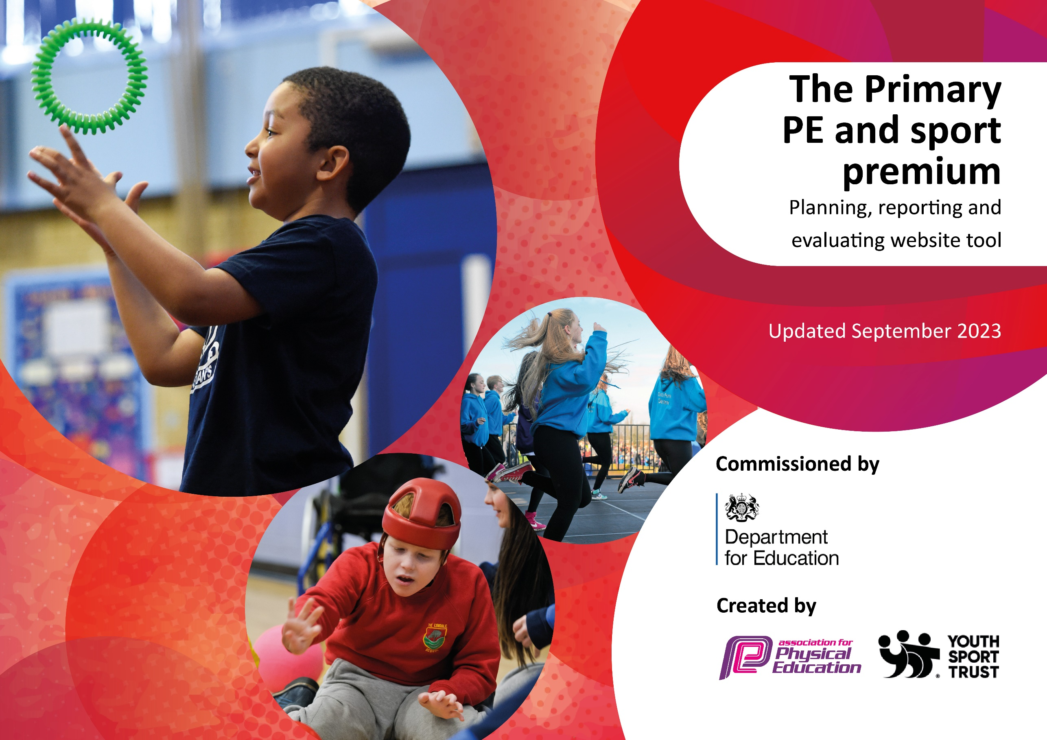

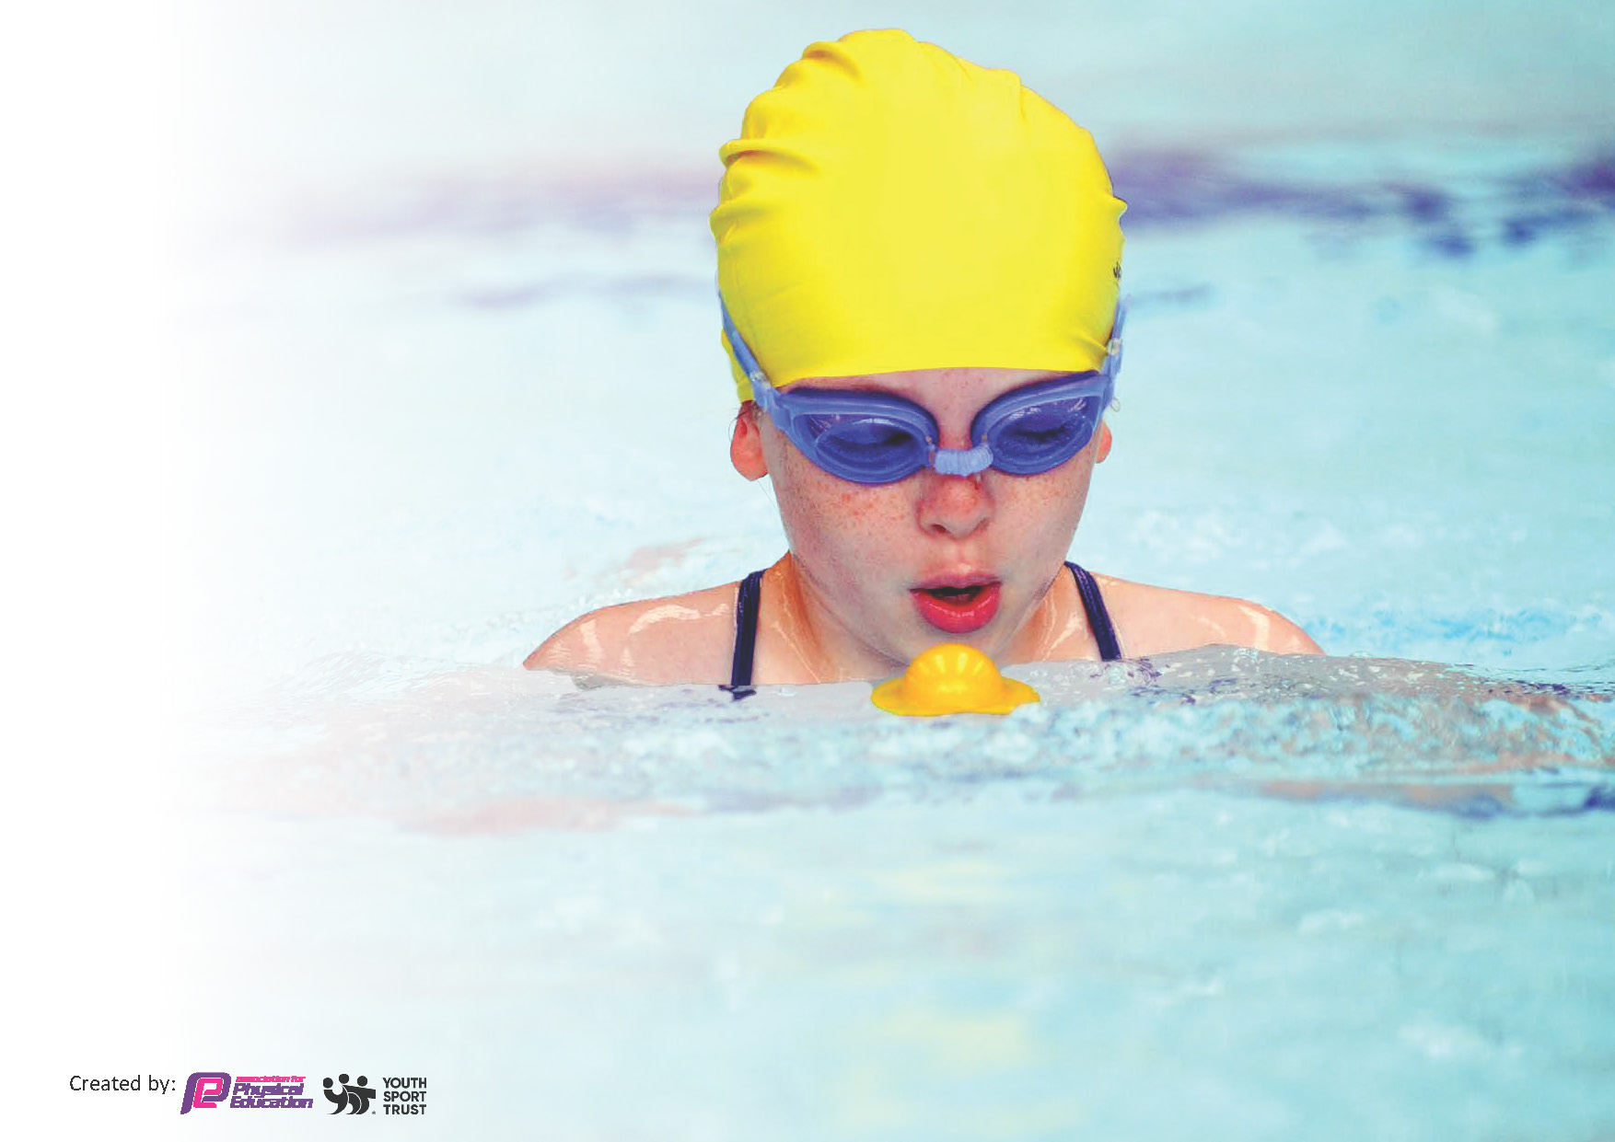
This template can be used for multiple purposes:
by:
- It enables schools to effectively plan their use of the Primary PE and sport premium
- It helps schools to meet the requirements (as set out in guidance) to publish information on their Primary PE and sport premium
- It will be an effective document to support Ofsted inspections enabling schools to evidence progress in Physical Education (PE) and evidence swimming attainment, which forms part of the PE National Curriculum. We would recommend schools consider
the Intent, Implementation and Impact of any spend, as examined within the Education Inspection Framework.

It is important that your grant is used effectively and based on school need.

Schools must use the funding to make additional and sustainable
improvements to the quality of the PE, School Sport and Physical Activity (PESSPA)
they offer. This means that you should use the Primary PE and sport premium to:

- Build capacity and capability within the school to ensure that improvements made now will benefit pupils joining the school in future years
- Develop or add to the PESSPA activities that your school already offers.

The Primary PE and sport premium should not be used to fund capital spend projects; the school’s core budget should fund these. Further detail on capital expenditure can be found in the updated Primary PE and sport premium guidance.

The Primary PE and sport premium guidance, outlines 5 key priorities that funding should be used towards. It is not

necessary that spending has to meet all the key priorities, you should select the priorities that you aim to use any funding towards.

Although completing this template is not a requirement for schools, schools are required to publish details of how they spend this funding. Schools must also outline what the impact this funding has had on pupils’ PE and sport participation and attainment and how any spending will be sustainable in the future. All funding must be spent by 31st July 2024.

The Department for Education has worked closely with the Association for Physical Education (afPE) and the Youth Sport Trust (YST) to develop this template and encourages schools to use it. This template is an effective way of meeting the reporting requirements of the Primary PE and sport premium.
Review of last year’s spend and key achievements (2022/2023)

We recommend you start by reflecting on the impact of current provision and reviewing your previous spend.

Activity/Action | Impact | Comments
- Engage children into sport with active learning by joining the SSP (£1600)  - Active maths with Owen afternoon with whole school in hall (£1000)  - Personal Challenge Week/Promoting personal challenge in and out of the school setting.  - Whole school training in first aid to give children basic lifesaving (£975)  - Implement physical activity and health and well-being clubs to children  - - To increase the levels of activity of foundation stage children during outdoor learning/ Improvements to playground including: line markings to form a race track.  - Continue to Promote PESSPA through the delivery of Healthy and Active Lifestyle Club -Children to learn about leading healthy lifestyles -Children to make independent choices to participate in physical activity  - Clear focus on children using teamwork and communication during sports (promotion of the School Games Value)  - - Continue to offer pupils the opportunity to take part in a range of intra/inter-school competitions | -Children were able to go to a range of events throughout the year.  -The children were able to achieve a range of medals and trophies for their achievements.  -PE mats provided for P.E. Lessons.  -increased the interest in school sports and competitions  - children were all engaged and staff members have begun to use these strategies in their learning  - Children are all aware of personal challenge and complete these twice every half term. Children are engaged and more active as a result.  -developed on previous years of knowledge with clear progression  - Well-being areas are now in dedicated areas within the school and children can access these at any time  -A thorough list of children who benefitted from the interventions has been established and these are continuing into 23/24  -Children are more active during break times/outdoor learning opportunities.  - Children have had access to active break/lunch times through Y5 young leaders supporting with games.  - Sports/game equipment taken out on break/lunch times to increase physical activity and increase participation.  -Children introduced to School Games Values and these are promoted throughout P.E. Lessons and active learning opportunities.  - Children have taken part in a range of intra and Inter competitions through the SSP. We have aimed to provide a range of competitions and competed in the Primary swim gala for the first time. This helped to increase participation of KS2 children. | -This will continue this academic year 23/24 so that we can continue to work with SSP.  -To continue to have Owen provide resilience workshops with the children  -Personal challenge will continue to be implemented in 23/24  This will continue throughout every academic year  -Links with Compass GO and their provision have now taken over  - Compass Go has helped to identify children that can act as mental health ambassadors for their peers.  - To be continued in 2024/25  £500

Key priorities and Planning
This planning template will allow schools to accurately plan their spending.

Action – what are you planning to do | Who does this action impact? | Key indicator to meet | Impacts and how sustainability will be achieved? | Cost linked to the action
-Staff to receive ongoing CPD by shadowing high-quality expert coaches in a range of sports.  -Staff ‘up-skilled’ in a range of sports so that delivery in future years is of a high quality.  - Increase staff confidence, skills and knowledge in P.E and the progression of skills.  Subject leader to attend P.E subject leader meetings/CPD  - Increase pupil participation in physical activity within and beyond the curriculum offer  Engage more pupils in physical activity during P.E time ensuring every pupil has access to high quality equality equipment.  -Continue to offer a wide range of sports both within and beyond the curriculum in order to get more pupils involved- Affiliation with the SSP  - Continue to offer pupils the opportunity to take part in a range of intra/inter-school competitions  - Opportunities for pupils to meet famous athletes/ athletes with disabilities.  -Continue to provide opportunities for all when taking part in inter sports competitions  Implement physical activity and health and wellbeing clubs to support pupils • Low self-esteem • Low attainment • Least active  -Introduce wall chart that tracks pupils engagement in sport  -Mental health support for children (gardening and ELSA support) | -Curriculum specialist Owen D to provide staff CPD opportunities. Owen to deliver outstanding P.E lessons, staff meetings.  -Owen to support staff CPD through offering changes to current curriculum and feedback any changes to teachers and support staff to ensure consistency in approach.  Abbie Randell to attend CPD and subject leader meetings run by the SSP to improve whole school approach to P.E. Pupils will then benefit from high quality lessons.  Lunchtime supervisor’s / teaching assistants/Young leaders in year 5 to deliver games/sporting opportunities during break and lunch times.  Pupils – promotion of active learning and increased participation.  Pupils- by ensuring that we have up to date and high quality equipment we can ensure pupils are more engaged and increase participation in sport.  Pupils are given a broad range of sporting opportunities and will ensure more children are meeting the physical activity guidelines per day.  - Pupils can take part in intra and inter school competitions. Increasing their participation and engagement and promoting and active lifestyle through enjoyment in sport.  - Promotes the children’s perseverance and resilience and promotes a fully inclusive sporting environment.  - Pupils are provided with opportunities to take part in sporting events.  - -Yearly plan to be distributed to staff members attending. -Provide training sessions for children to up-level their skills  -Improve pupils physical and mental health. Provide interventions to least active/ low self-esteem and low attainment pupils. -Part fund ELSA - -Provide a specific area in the school where children can develop skills which are not necessarily ‘physical’ -Have interventions throughout the school day and lunch times to ensure targeting the correct children -Refresh of resources to ensure that children have access to high quality games and resources.  -Improve children’s mental health and wellbeing by offering ELSA and gardening opportunities. | Key Indicator 1: Increased confidence, knowledge, and skills of all staff in teaching PE and sport.  Key Indicator 1: Increased confidence, knowledge, and skills of all staff in teaching PE and sport.  Key Indicator 1: Increased confidence, knowledge, and skills of all staff in teaching PE and sport.  Key indicator 2: The engagement of all pupils in regular physical activity – the Chief Medical Officer guidelines recommend that all children and young people aged 5 to 18 engage in at least 60 minutes of physical activity per day, of which 30 minutes should be in school.  Key indicator 4: Broader experience of a range of sports and activities offered to all pupils.  Key indicator 2: The engagement of all pupils in regular physical activity – the Chief Medical Officer guidelines recommend that all children and young people aged 5 to 18 engage in at least 60 minutes of physical activity per day, of which 30 minutes should be in school.  Key indicator 4: Broader experience of a range of sports and activities offered to all pupils.  Key Indicator 5: Increased participation in competitive sport.  Key indicator 4: Broader experience of a range of sports and activities offered to all pupils.  Key Indicator 5: Increased participation in competitive sport.  Key indicator 4: Broader experience of a range of sports and activities offered to all pupils. | Staff to become more confident when Teaching P.E. Staff to better understand skills progression in P.E and deliver outstanding, high quality P.E lessons. This in turn will directly impact pupils and increase participation and engagement in PE.  P.E Coordinator to increase knowledge and skills of PE and best ways to provide better opportunities for the children and promote physical activity.  More pupils meeting their daily physical activity goal, more pupils encouraged to take part in PE and Sport Activities.  More pupils meeting their daily physical activity goal, more pupils encouraged to take part in PE and Sport Activities. Pupils to have access to better equipment allowing them opportunities to have outstanding PE lessons.  School to sign up with SSP each year to provide a consistent, high quality experience for pupils. Offer pupils a range of competitions, activities and positive sporting experiences.  Pupils to engage in competitions to increase in confidence. | £1000  PGL £4000  Pivotal skills £3484.76  £800 resources/equipment  £1715 Coaches for sporting events.  School  Sport  Partnership (1600)  £3000 Nurture/ELSA resources.  Total spent:  £16,034.76

.

Key achievements 2023-2024
This template will be completed at the end of the academic year and will showcase the key achievements schools have made with their Primary PE and sport premium spending.

Activity/Action | Impact | Comments
Achieving Gold in the School Games mark.  Providing a range of sporting opportunities-including swimming and Parkour. | We have evidenced the implementation we have in place to provide children with 30 active minutes per day. We have provided CPD opportunities for staff, provided a range of extra-curricular and inter competition opportunities for children.  Children have been given a broad range of sporting opportunities and we have targeted children with low self-esteem to build up confidence. | We are aiming to be awarded with the Gold school games mark again in 2024/25.

Swimming Data
Meeting National Curriculum requirements for swimming and water safety.
Priority should always be given to ensuring that pupils can perform safe self-rescue even if they do not fully meet the first two requirements of the National Curriculum programme of study

Question | Stats: | Further context  Relative to local challenges
What percentage of your current Year 6 cohort can swim competently, confidently and proficiently over a distance of at least 25 metres? | 100% | Use this text box to give further context behind the percentage.  e.g., 30% - we are struggling to get pool space due to our local pool closing so we have had to use a much smaller local school pool. We have had to limit the number of pupils attending swimming lessons during one term which means some pupils have attended fewer swimming lessons than others.
What percentage of your current Year 6 cohort can use a range of strokes effectively [for example, front crawl, backstroke, and breaststroke]? | 100% | Use this text box to give further context behind the percentage.  e.g., Even though your pupils may swim in another year please report on their attainment on leaving primary school at the end of the summer term 2024

What percentage of your current Year 6 cohort are able to perform safe self-rescue in different water-based situations? | 100% | Use this text box to give further context behind the percentage.
If your schools swimming data is below national expectation, you can choose to use the Primary PE and sport premium to provide additional top-up sessions for those pupils that did not meet National Curriculum  requirements after the completion of core lessons. Have you done this? | Yes/No
Have you provided CPD to improve the knowledge and confidence of staff to be able to teach swimming and water safety? | No | N/A staff delivering sessions are trained specialists.

Signed off by:

Head Teacher: | (Name)
Subject Leader or the individual responsible for the Primary PE and sport premium: | Abbie Randell P.E. Coordinator
Governor: | (Name and Role)
Date:

