
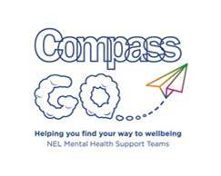
Covid-19: supporting Primary school children

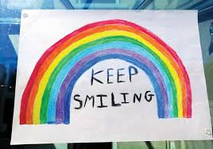
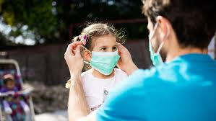

The corona-virus has had a big impact on everyone. It may have stopped you from spending time with family and friends, and at the moment schools are closed, so your daily routine will be different. Some people will have lost family members, and other people may have lost their jobs. It has had an impact on everyone in some way.
It is normal to feel worried about the virus, but if you worry too much about something then it can make you feel poorly and stop you doing things you may usually do. It is important to share your worries with an adult to that they can help you learn new ways to deal with your worries.
Have a look at some of the resources below which may be helpful and follow these 5 tips to improve your emotional wellness:
Connect: Keep in touch with your family, friends and school – video call, or send a letter.
Keep active: Try Joe Wicks PE or set yourself a daily challenge
Take notice: Focus on the here and now and give your mind a break, try a scavenger hunt around the garden.
Keep learning: Not just school work, but try something new at home – create a picture using things you find in your garden, or learn a new language using an app
Give: Make someone smile, give a compliment, bring your parents drink and biscuit
Useful Resources
NEL COVID support line (24/7) 01472 256256
https://nosycrow.com/wp-content/uploads/2020/04/Coronavirus-A-Book-for-Children.pdf
https://www.nspcc.org.uk/keeping-children-safe/coronavirus-advice-suppport-children-families-parents/
https://www.elsa-support.co.uk/health-and-wellbeing-during-the-coronavirus-outbreak/ https://www.elsa-support.co.uk/wp-content/uploads/2020/03/Coronavirus-Story-in-English.pdf
