Year 5 Writing 13/7/20
Letter to my new teacher 2020
Your challenge:
This is a new and unusual time for everyone. You may not get the chance to meet your new teacher before you go back to school but teachers love to receive letters from you.
Write a letter to your new teacher. Use this letter to tell them more about you and what you did during the spring and summer of 2020.
Tell them about yourself, your interests and hobbies and any fun facts about yourself.
What have you enjoyed during the spring and summer and what have you learnt?
What wishes do you have for Year 6?
The more you include in your letter the more your teacher will learn about you.
Remember to illustrate your letter to make it look nice and maybe you could draw a portrait of yourself.

Activity 1 - Plan
Use the questions in this plan to make notes of what you will include in your letter.

Introduce yourself:
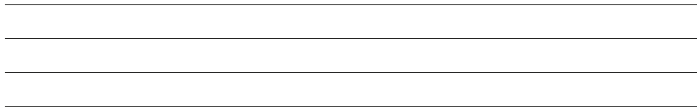
What are your interests, hobbies, favourites, any fun facts about yourself?

What did you enjoy during the school closure?
What did you learn while the schools were closed?
What wishes and goals do you have for Year Six?
Anything else you would like to ask your teacher about herself or Year Six?
Remember, I know how fantastic you all are! Tell your new teacher about your strengths in different areas of the curriculum (e.g. amazing mathematician who loves a challenge, super sportsman who enjoys playing cricket, talented artist, scientist…) and maybe some areas that you would like to improve


Activity 2: Use your plan to draft a letter

Activity 3: Publish - use the layout features in this example to help you write your letter in your best handwriting. Remember to ‘show off’ and impress your new teacher!

