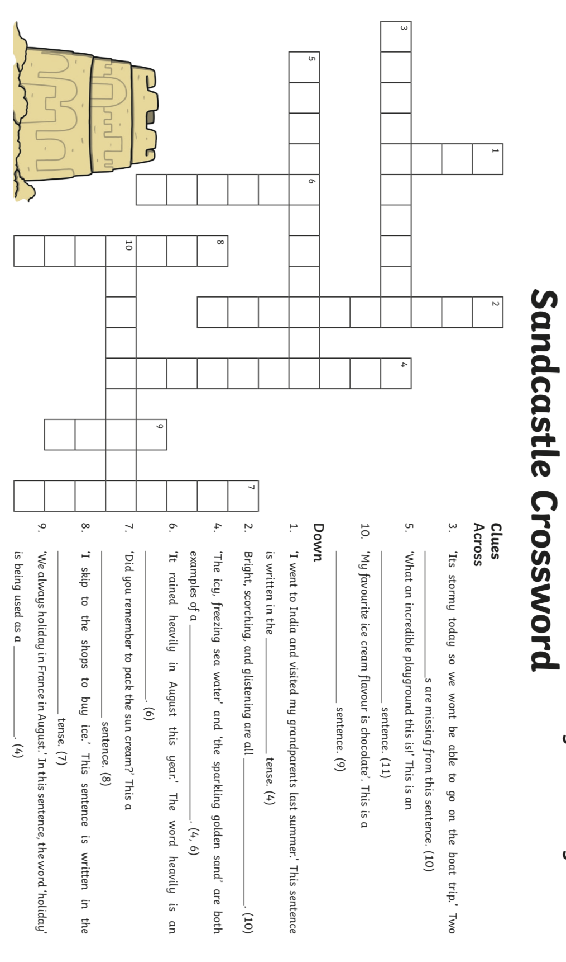
Lesson 3
SPaG Crossword

