Lesson 1
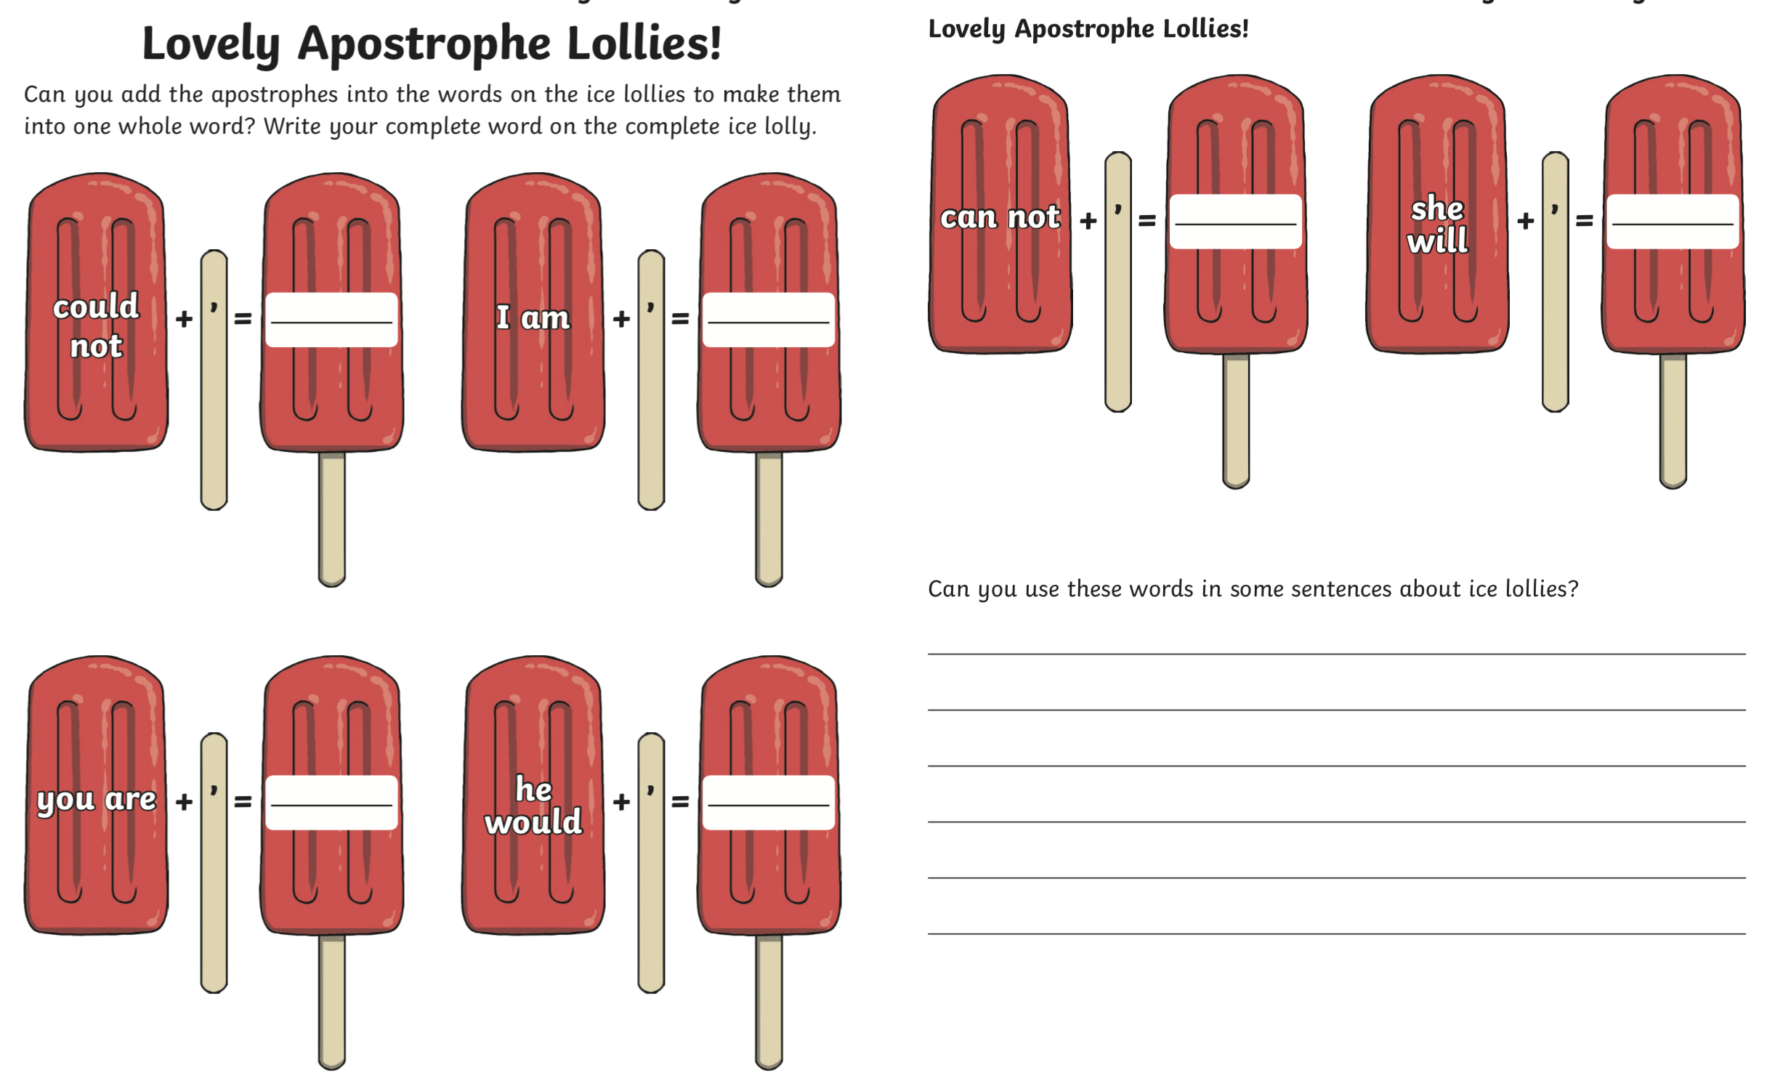
Apostrophes for contractions

