Year 3 & Year 4 Writing Week 6

Miss Dalmedo visited Alcatraz a few years back and thought that you would like to see her pictures that she took when visiting
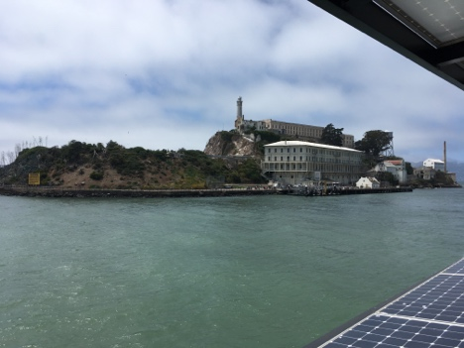

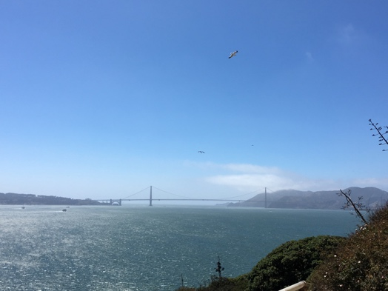

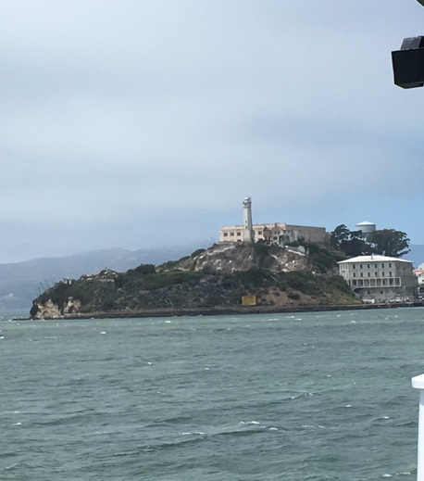

Lesson 3 – To be able to plan a newspaper report

Today is about using the information you have found to plan the order of your report. Remembering the 5 W’s!

The 5 W’s
Who?
What?
Where?
When?
Why?
Activity:
To place the main facts and events in the correct order on the template.

Success Criteria:
- Headline (rhyme, alliteration or pun)
- Introductory paragraph (who, what, where, when and why)
- Subtitles
- Chronological order
- Third person and past tense
- Picture with a caption
- Formal language
- A conclusion of what might happen next in the future

