Year 3 & Year 4 Writing Week 6

Lesson 2 – To be able to identify the features of a newspaper report

Let’s run through some of the features before identifying them in your report.

Formal writing with a serious tone.

Audience – A reader and buyer of the newspaper.
Purpose – To inform readers and tell them about something they did not know or add to their knowledge.

Features
- Headline
This should be larger and bolder than the rest of the newspaper report so that it grabs the reader’s attention.
- First Paragraph – The hook
This should clearly summarise the whole newspaper article. It should be larger and bolder than the main text of the newspaper report.
- Image and caption
The image (e.g. a photograph or diagram) should grab the reader’s attention. There should be a caption underneath to describe the image.
- Paragraphs
The newspaper report should be organised into paragraphs to help the reader make sense of the story.
- Sub-headings
Short titles will tell the reader about what that paragraph or section of text will be about.
- Columns
Newspaper reports can be written in columns.
- Concluding Statement
A concluding statement can sum up the story. Sometimes they can offer an opinion about the story, use a rhetorical question or guide the reader as to where they can find more information.
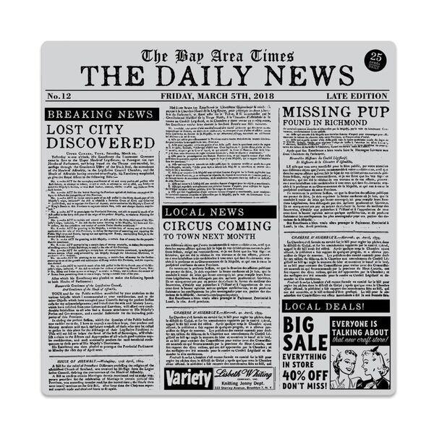

Task 1:
Annotate the article about tennis to identify structural features.
Use a ruler to label around the article.
Headline, image, caption, the hook, columns, paragraphs, concluding statement

Task 2:
Create a colour key code to highlight and identify the language features in the news article.
Third person, past tense, facts, quotes, rhetorical questions.

