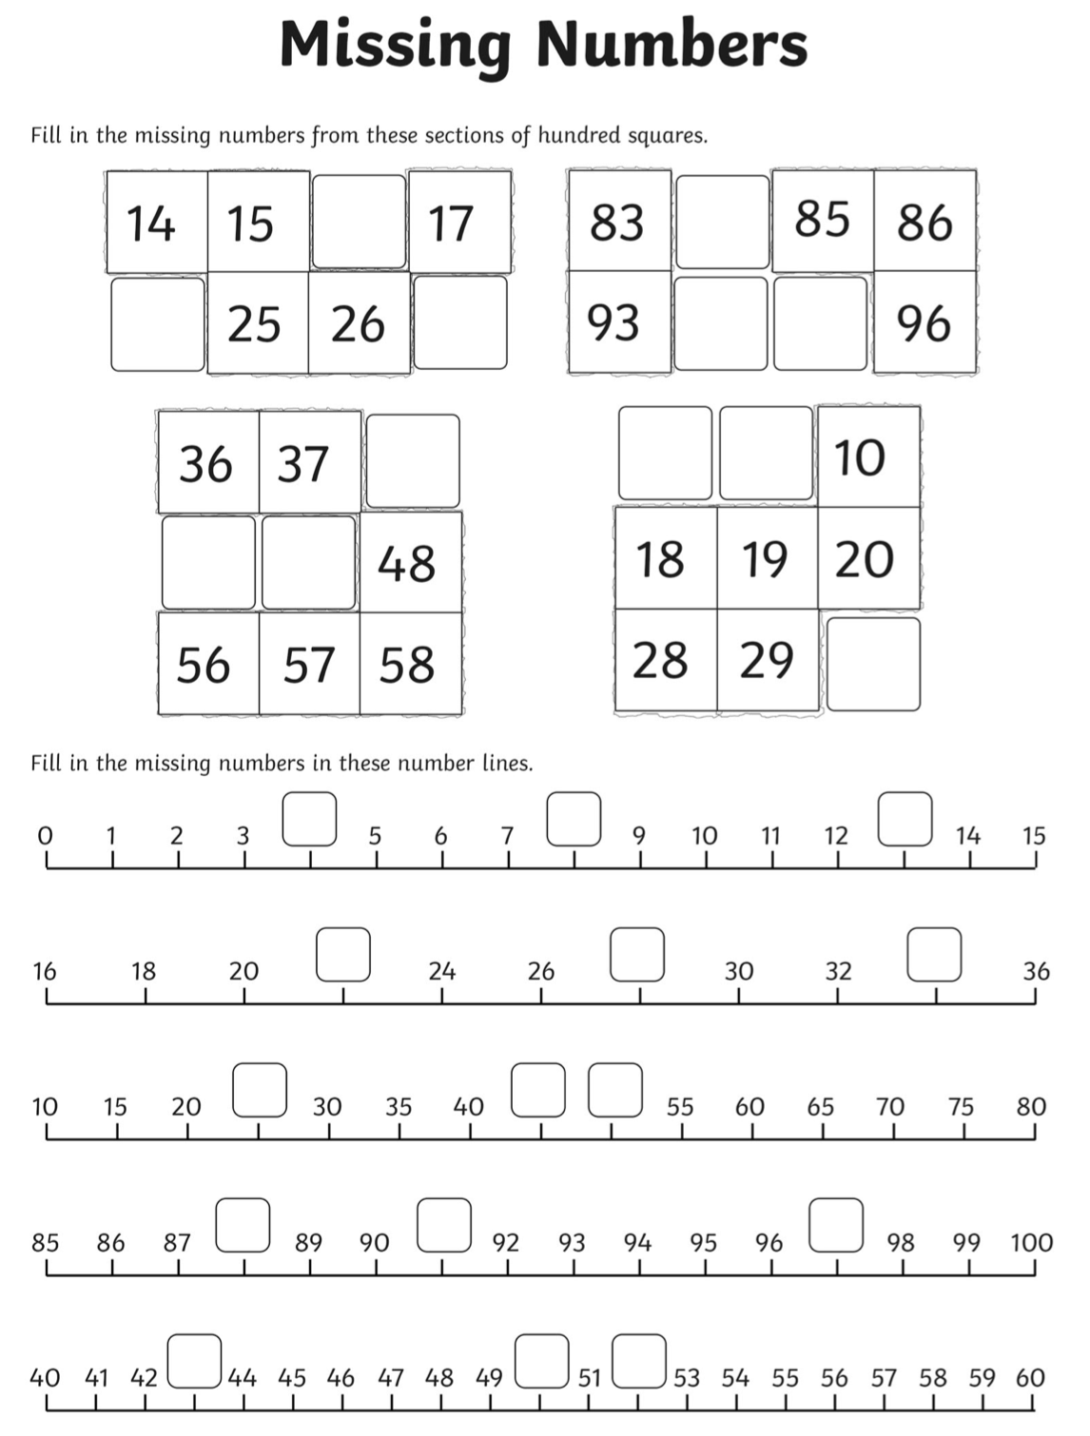
Lesson 4

Challenge: Can you make your own number line for numbers past 100?

