Lesson 5 Week 6 Year 4 Maths

Reading coordinates
Coordinates are numbers which determine the position of a point or a shape in a particular space (a map or a graph). Coordinates are ordered pairs of numbers; the first number indicates the point on the x axis and the second the point on the y axis.

When reading or plotting coordinates you always go across first and then up (a good way to remember this is: 'across the landing and up the stairs').

Read Coordinates

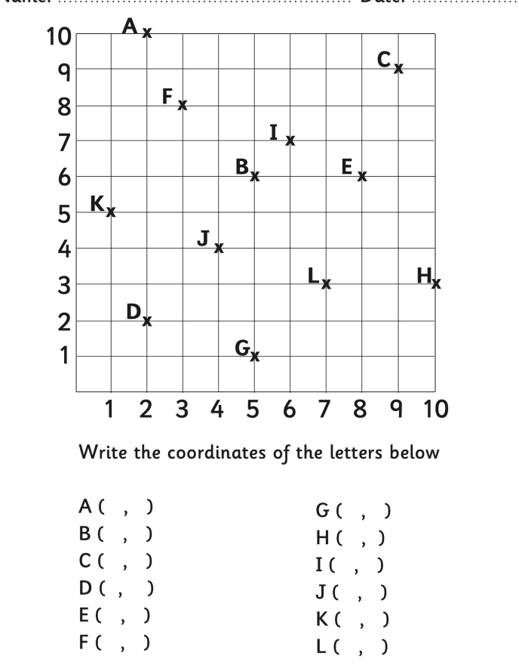

Reading and Plotting Coordinates

