
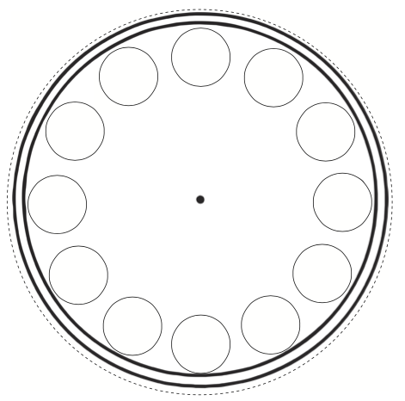
Make your own clock using a paper plate, by cutting a circle out of cardboard or use the template below. Use a real clock to help you to write the numbers correctly, it’s just like a circular number line to 12! Remember we don’t say 13, we go back to 1. Make an hour hand for your clock or use the one below and practice telling the time to the hour. You could set the clock to different times to help you know when it is time for something, e.g. when tea time is or bed time. Can you tell your adult what time it will be one hour later or one hour before different times?

