Year 3 & Year 4 Writing Week 5

Lesson 4
To be able to write an action story opening

Examples –

The Shadows
Desperate for help, Cassie darted through the foggy wood, her breath uncontrollably wheezing. Heavy footsteps approached Cassie. Closer. Closer. Silence. Cassie was terrified. She wanted to turn around, but she held her curiosity back. Why did it stop? Did it give up? The questions whizzed through her mind in a whirl of confusion. Suddenly, a bright light was seen ahead...
Freaky forest
Without hesitating, Leo darted towards the open light, his legs bent and fell but still he carried on. His companion slowly faded away and the barking and yelling came closer. A sudden blood curdling growl broke the deadly silence, he ran as fast as his legs could carry him on and on. The aggressive growling snapped at his tail.
Then all of a sudden, Leo spotted a huge pile of brambles tossed beside the soggy leaves. Uncontrollably Leo jumped over, covered in sharp thons into a bare burrow. All around him silence occurred, with the occasional drip of rain from the tree above and the wind howling through the thicket.
Story openers starter ideas:
- The eyes in the painting follow him down the corridor.
- Everything stopped, people were stood like statues all around me, people in cars, men on bicycles, babies in prams all lifeless, frozen in time.
- Peeking through the window her surprise turned to horror...
- The clock stopped... 74 minutes past 18...it was time to get up.
- 'I pushed open the old creaky door and looked inside. What a sight met my eyes!'
- The ground was shaking beneath me.
- Devastation surrounded me.

Success Criteria:
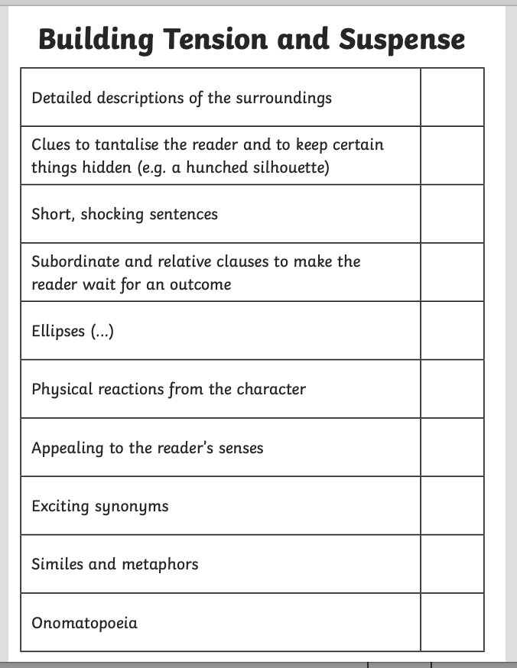

Draft:


