Year 3 & Year 4 Writing Week 4

Lesson 2
To be able to build descriptive sentences

Today is all about building descriptive sentences. These will be so useful to have when we get to writing our draft story opening. Remember the planning stage of writing is the most important, so try to be as descriptive as you can be!

Success Criteria:
- Powerful adjectives
- Similes
- Adverbial phrases
- Expanded noun phrases
- 5 senses
- Atmosphere

Starter – To get your imagination flowing, let’s start with warming up our 5 senses

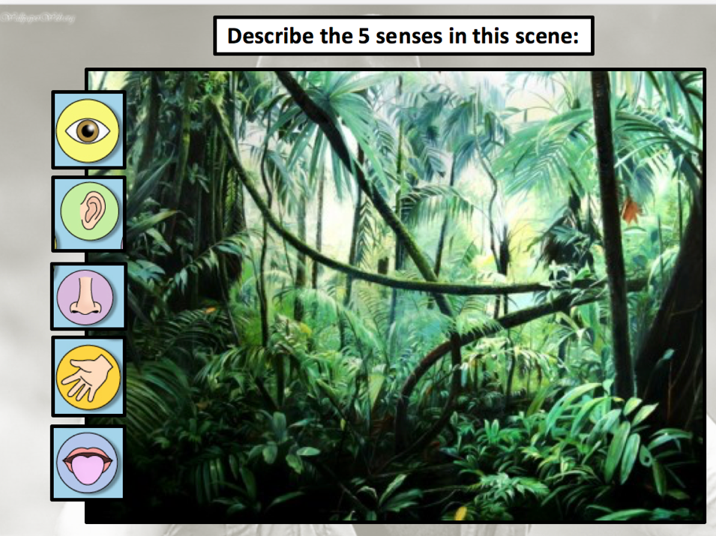

-
-
-
-
-
-
-
-
-
-
-
-
-

Main - Boring sentences for you to improve:

The man was scared.

_____________________________________________________________________________________

Mountains covered with sharp edges.

There were people everywhere.

______________________________________________________________________________________

Cobwebs hung from the mossy cave ceilings.
_____________________________________________________________________________________

Can you create 5 of your own about this image? Set the scene







