Lesson 4 Week 5 Year 4 Maths – Angle Problems

Today and tomorrow you will be applying your learning to solve a mixture of problems. Remember to read the question carefully and fully explain your answers. You may need to refer to your work from earlier in the week to help.

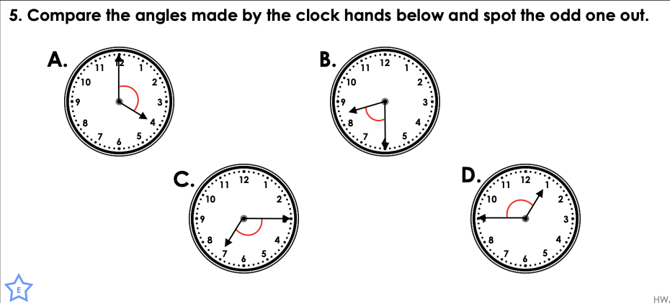
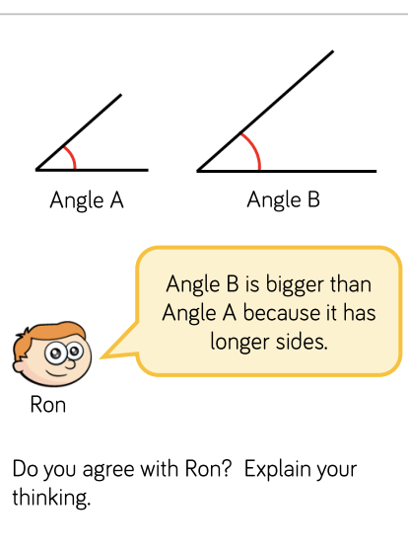

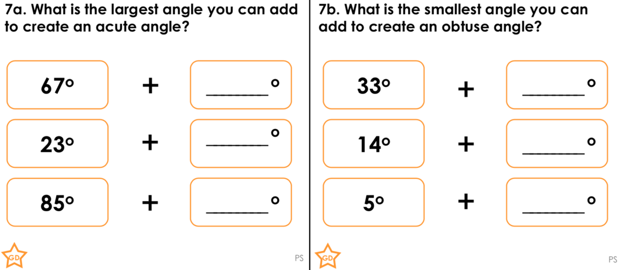

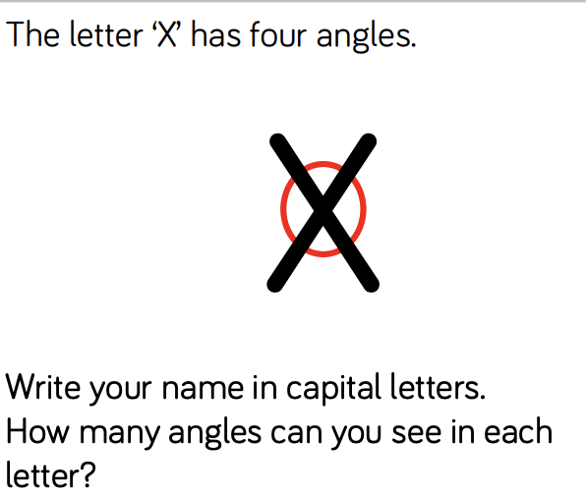

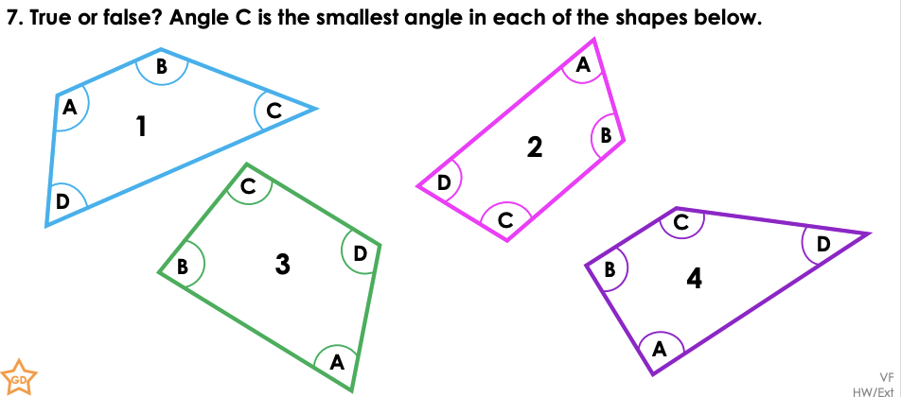

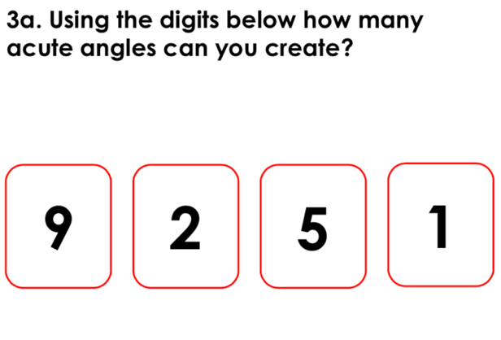

Challenge – Remember a straight angle is 180 degrees!

