Lesson 1 Week 5 Year 4 Maths -

In today’s lesson you will be working through questions about turns. The vocabulary you need to know to work through the sheet is below. You also need to know a quarter turn is 90 degrees, a half turn is 180 degrees, a three quarter turn is 270 degrees and a full turn is 360 degrees.
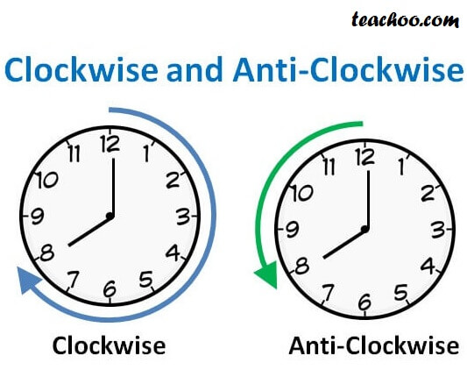
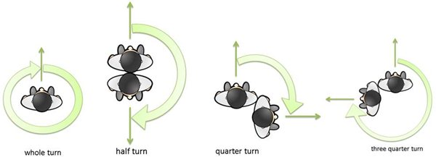

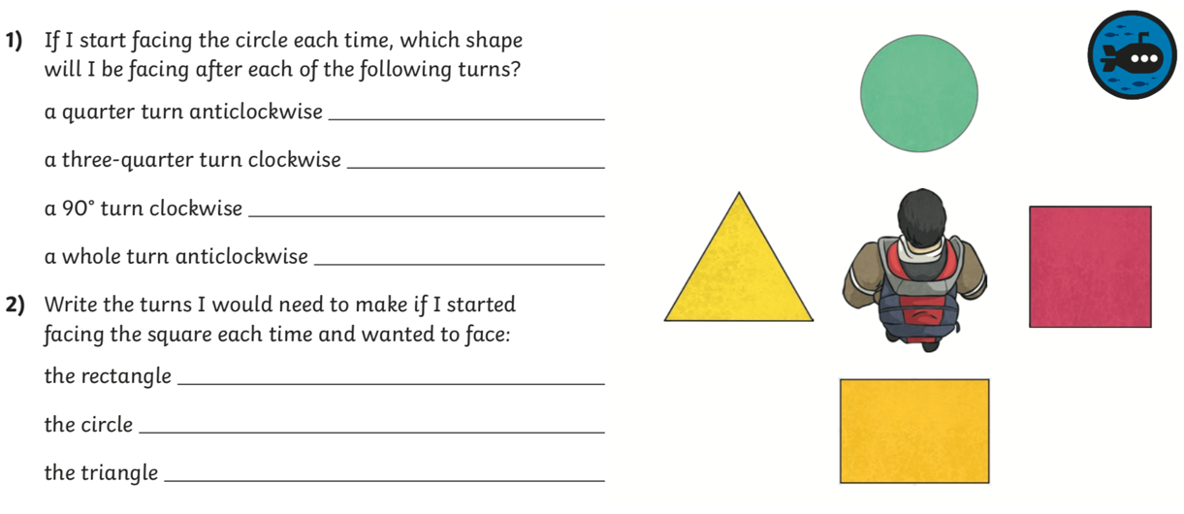
Questions
