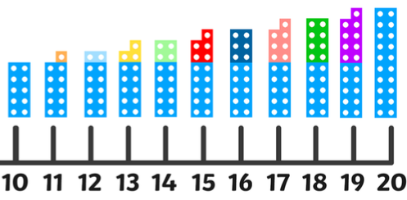
Can you write the number in numerals?
Can you draw the numicon piece for your number?
What is 1 more and 1 less than your number?
1 less 1 more
Can you write the number in words?

Can you make the number using the tens frames?
Can you draw your number?

