
Film Review


This week’s writing task is to review your favourite film, a film you really enjoyed recently or maybe one from your latest movie night.

Your review will:
- Inform
- Persuade

I would like to:
1. Find out about the characters and the plot (but don’t give too much away!)
2. Learn about the lead actors who star in the movie.
3. Find out why you enjoyed it and your favourite part.
4. I would like to be persuaded to watch it!

Task 1

Choose a film. You might want to watch it again first

Make some notes about the film:

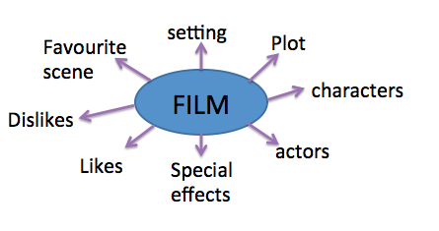


Task 2

Read the 3 example opening paragraphs.
Which do you think is the most successful?
Which makes you want to learn more about the film?

1. Do you want to be mesmerised by a worldwide classic? This award winning Disney + Pixar collaboration will do the trick. Ratatouille: an amazing, animated movie fit for all the family.

2. Are you sat scrolling through rows and rows of films but achieving no success of finding one you want to watch? I assure you, if you choose this, you will be blown out of your seat. You’ll be so explosively engaged, you will feel as though you are actually there, living the action with the characters. Every step of the way, you will be glad you discovered this masterpiece!

- Are you that person who hunts for hours on end, looking for a film for a spontaneous movie night? Well put the TV remote down and get ready for the best film night of your life. I fully understand that you think I am exaggerating - but let me explain…

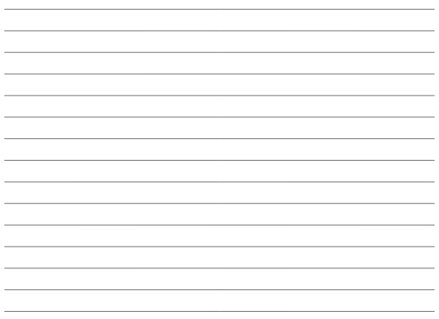
Have a go at writing a similar opening paragraph for your film.

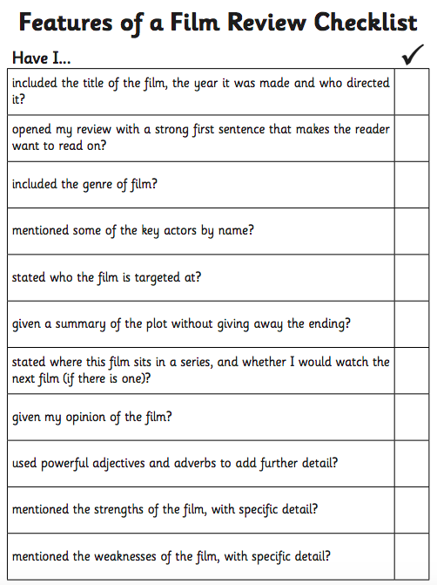
Task 3

Draft and edit

Example paragraph structure

2. Explain what the film is about. What genre does it belong to? Who are the actors?

3. The good points of the film. You could include your favourite part. Don’t forget to give reasons and ambitious vocabulary to describe.

4. Were there any bad points? Give your overall opinion if the whole film.

5. A sentence or two to persuade me to watch! Star rating?

