Year 3 & Year 4 Writing Week 5

Lesson 5 – Publish your story opening/whole story

Today is the big day where you are going to publish and bring your story to life, remembering you want it to be a big hit in Hollywood!

Start by writing it up in your best handwriting, maybe you want to improve as you go along or edit and improve beforehand by reading through and editing.

Narrowed line guide attached

After you have written it in best it is time to create a title and the front cover of your story! Be as creative as you can be

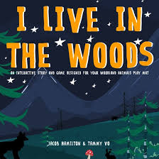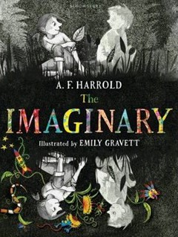

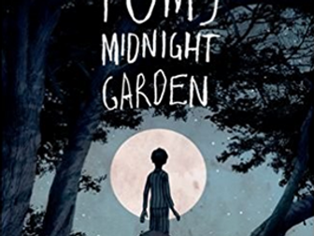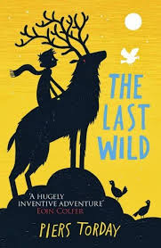

Front Cover

