Year 3 & Year 4 Writing Week 5

Lesson 3
To be able to write speech correctly

Top tips:

Direct speech is a sentence in which the exact words spoken are reproduced in speech marks (also known as quotation marks or inverted commas).
For example:
"You'll never guess what I've just seen!" said Sam, excitedly.
"What's that?" asked Louise.
"Our teacher has a broomstick and a black pointy hat in the back of her car. Maybe she's a witch!"
"No, silly! They're for the school play!" replied Louise, sighing.

The general rules of direct speech are:
- Each new character's speech starts on a new line.
- Speech is opened with speech marks.
- Each line of speech starts with a capital.
- The line of speech ends with a comma, exclamation mark or question mark.
- A reporting clause is used at the end (said Jane, shouted Paul, replied Mum).
- A full stop goes after the reporting clause.
- If the direct speech in the sentence is broken up by information about who is speaking, add in a comma or question mark or exclamation mark to end the first piece of speech and a full stop or another comma before the second piece (before the speech marks), for example: "It's lovely," she sighed, "but I can't afford it right now." / "I agree!" said Kate. "Let's go!"

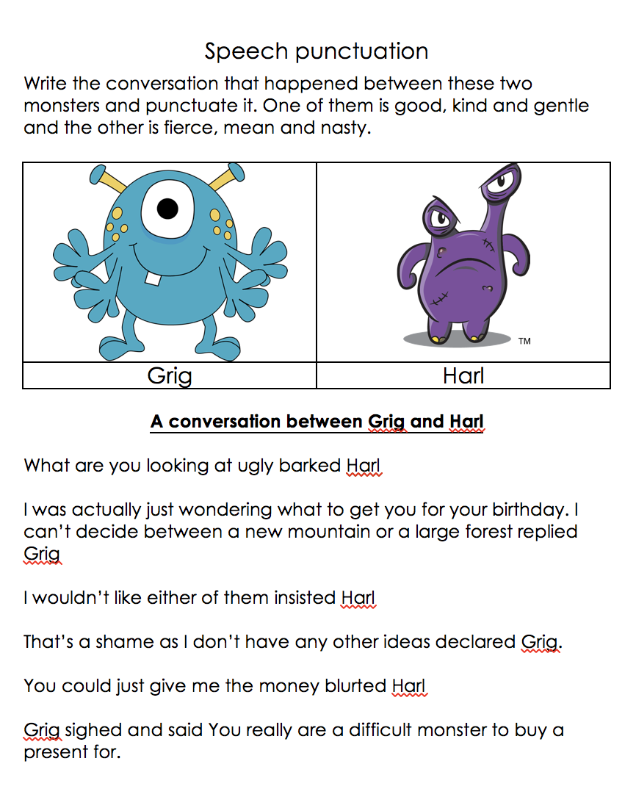
Starter

