Lesson 5
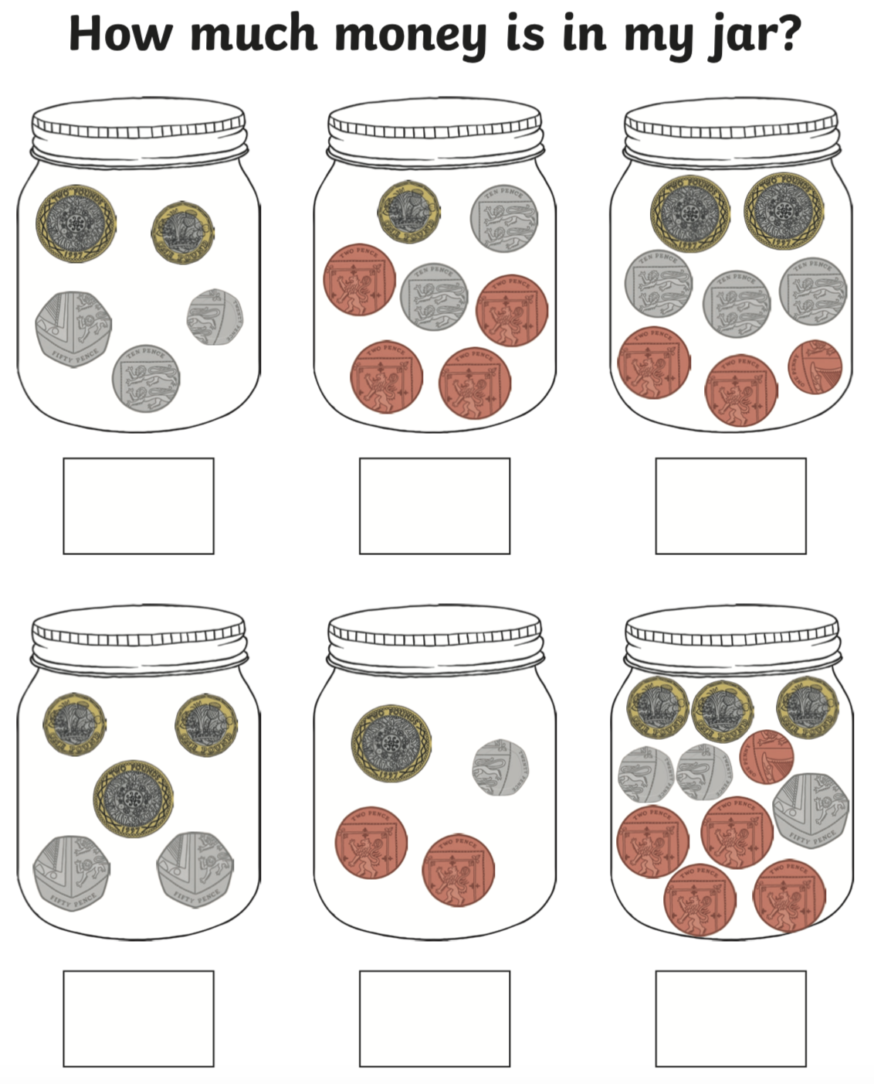
Counting Money

Answer these questions (don’t forget your symbol at the end)
- 90p – 50p =
- 55p – 23p =
- 47p – 34p =
Change from an amount
