Lesson 2
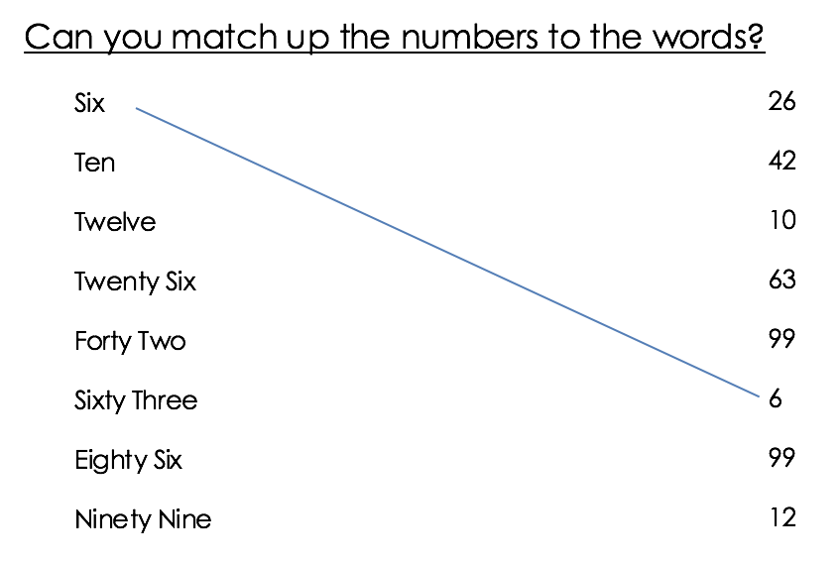
Read and write numbers in words and numerals

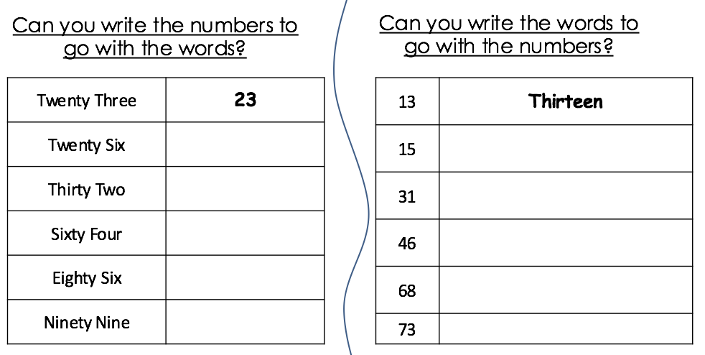

Challenge:

Try to write all the numbers from 0 to 100 in words and numerals.

