Lesson 1
Place Value
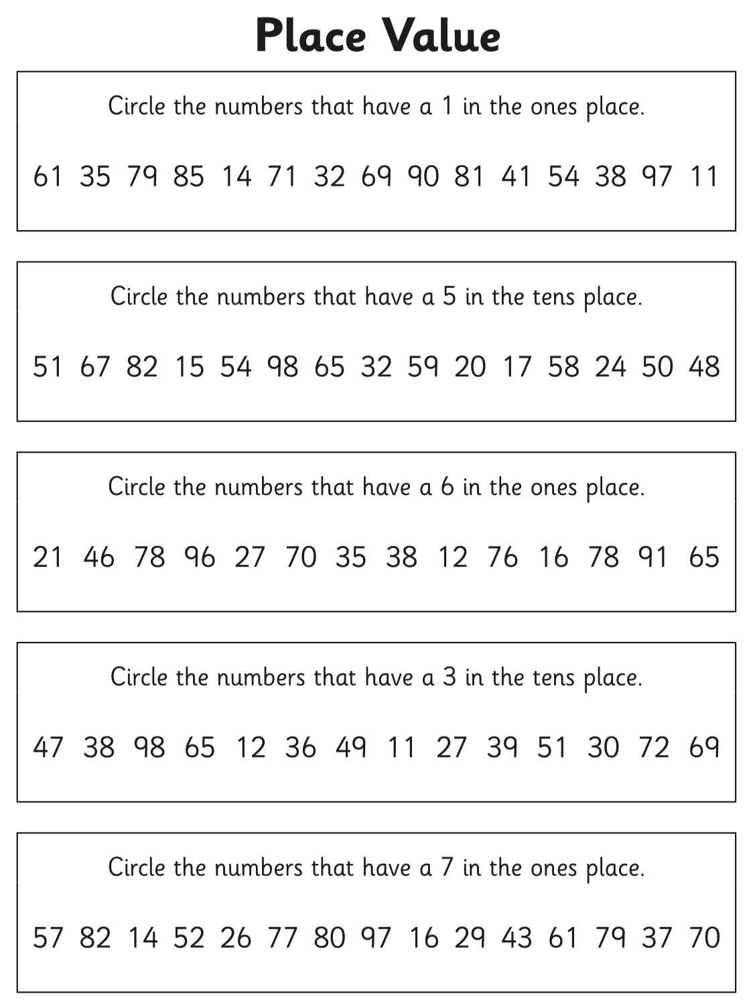

Challenge:
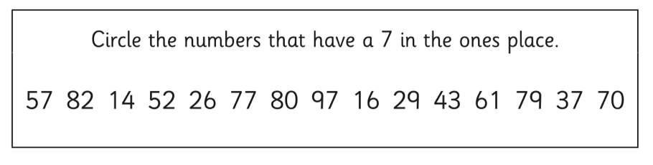
Circle the numbers that have a 2 in the hundreds place.

152 256 526 289 992 26 120 375 27 732

