Lesson 4
Money Combinations

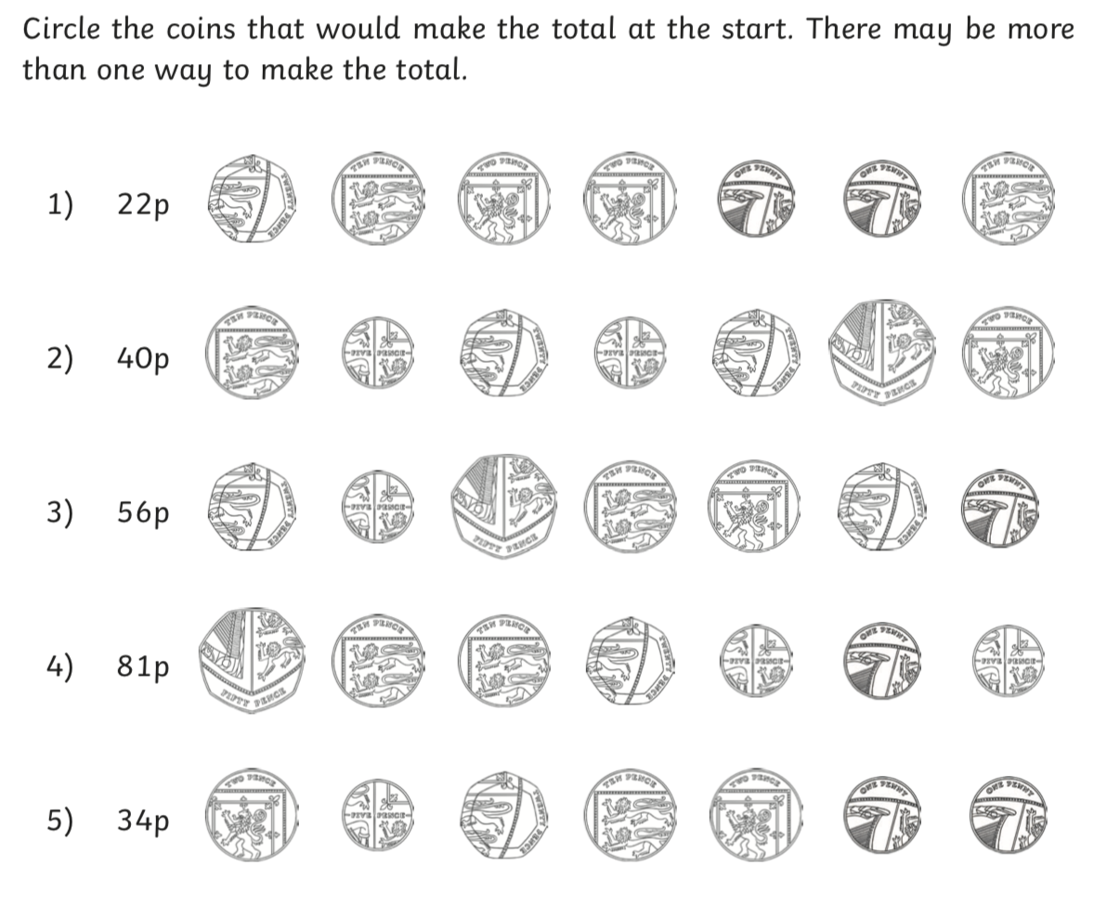

Challenge: How many different ways can you make 45p?

