Lesson 5
SPaG Mat

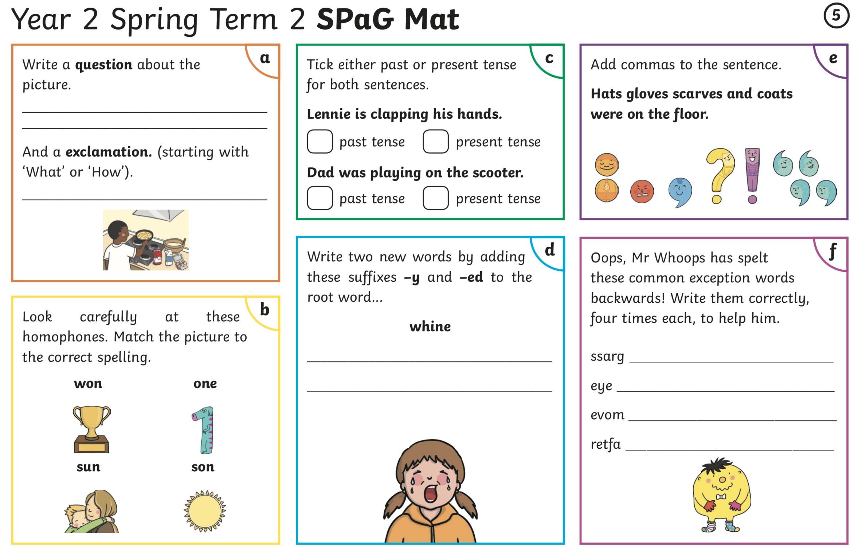
Complete the spelling, grammar and punctuation mat below.

