Maths 1
29.06.20

1. 9³ | 2. 25.6 x 3.8
3. 5⅗ x 3= | - 167 + ? = 824
5. 123.4 - 56.29= | 6. Draw a line perpendicular to this blue line:
7. Calculate the perimeter of this compound shape:  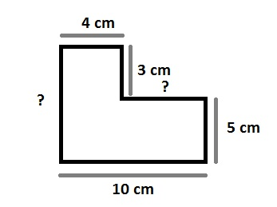 | 8. Calculate angle w  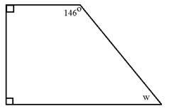
9.  What do you add to 0.26 to make 2? | 10. Calculate the area of the triangle:  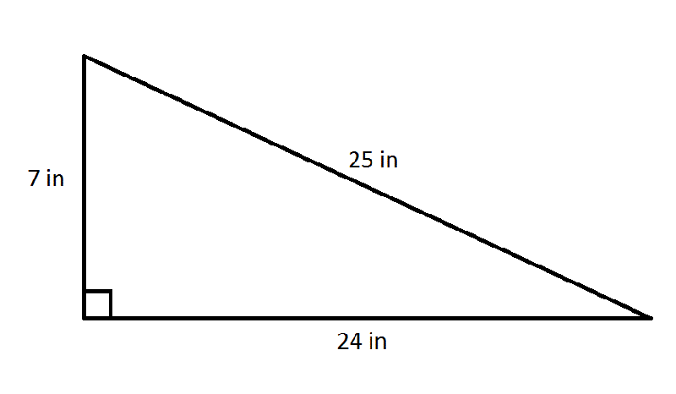
11. Calculate:  300 – (8² + 10²) | 12. 497 ÷ 4 =
