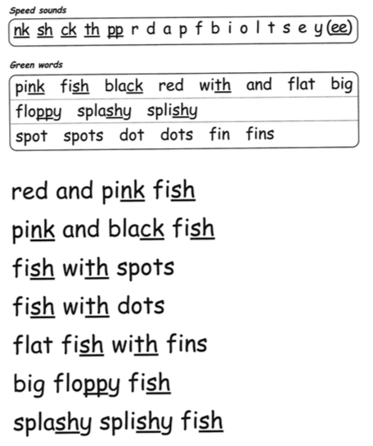
Hold a sentence

______________________________________
3rd July 2020
- Read the sounds in the top box, encouraging ‘pure sounds’ – no ‘uh’s!
- Read the ‘green words’ – words that can be segmented and blend together. Discuss here how the ‘y’ makes a ‘ee’ sound.
- Read the ‘red words’ – Word that cannot be decoded.
- Read the short story.
- Question to talk about – What different types of fish were there?
- Hold a sentence - Adult says the sentence and child repeats, have fun saying it in different ways: eg in a high pitched or deep voice, slowly or quickly or even sing it! The aim is for your child to hold the sentence in their head so that they can write it down with as few prompts as possible. Once they have written the sentence they should check that they have finger spaces between words and the sentence makes sense.

Today’s hold a sentence is: a fish can swim

