Year 5 Maths 30.6.20 - Factors and multiples
Example - Factors of 12: 1, 2, 3, 4, 6, 12
1
12

Factor: A number which goes into another number without leaving a remainder
x
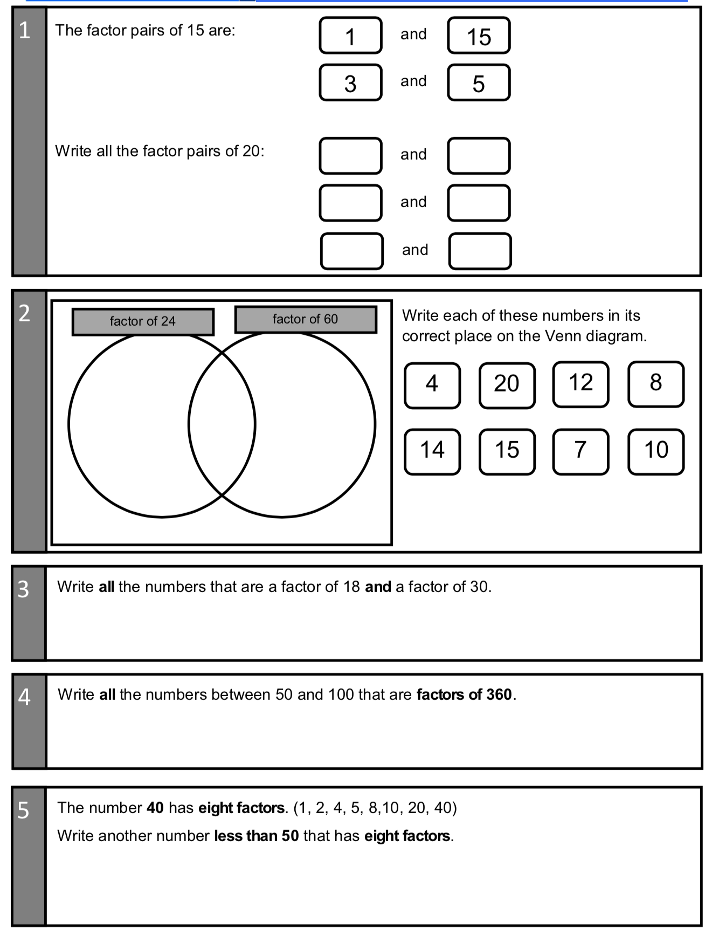
6
2
4
3
12
X

X

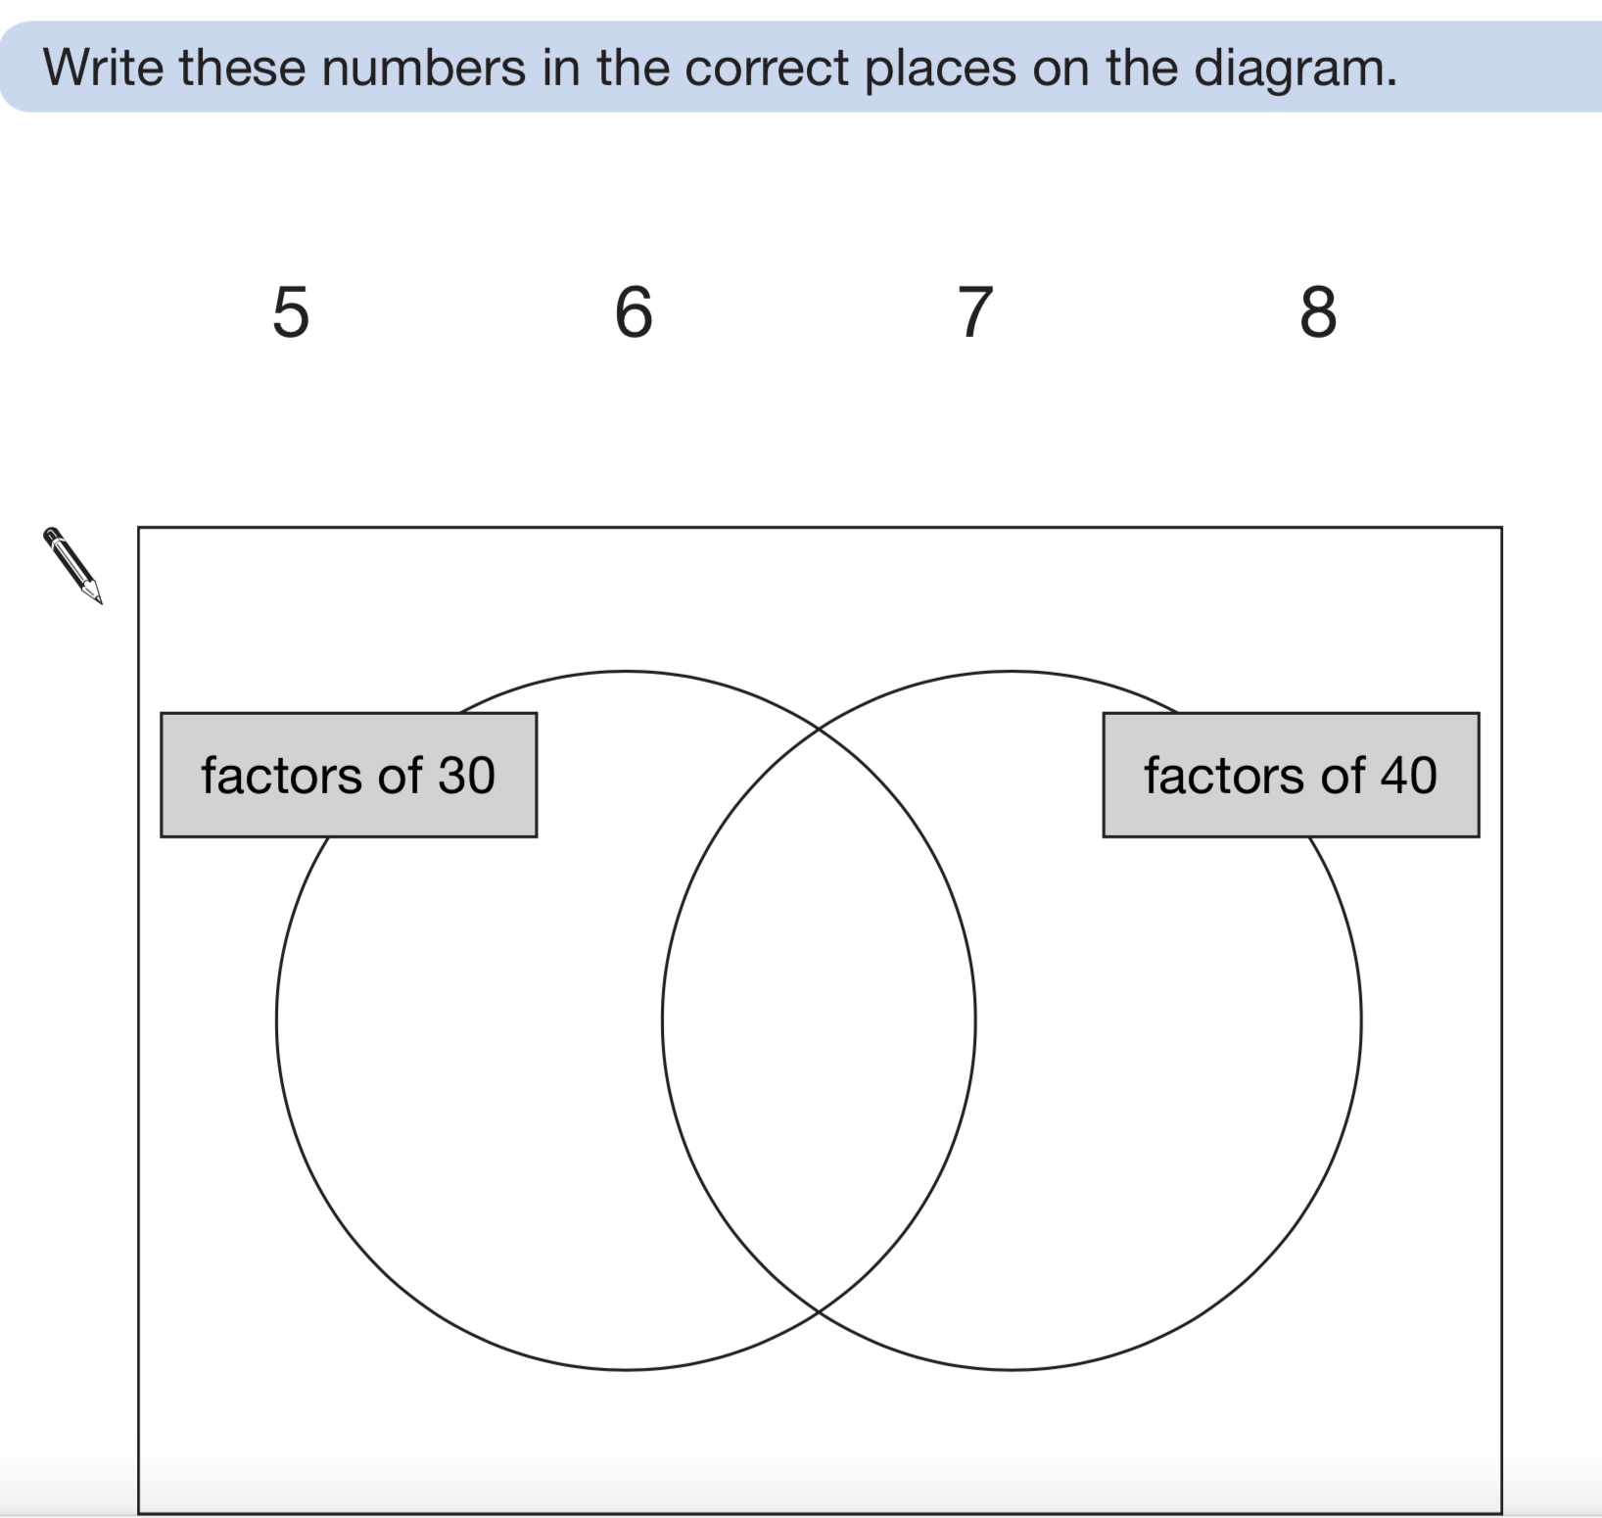

Example - Multiples of 4:
4, 8, 12, 6, 20…
