

Year 3 & Year 4 Writing Week 4

Lesson 5 – Publish you advert!

Now you have drafted, edited and improved your advert, it is time to send it to the publisher. Imagine that your advert will be posted in a magazine!

Success Criteria
- Bright and colourful
- Eye-catching title
- Neat and professional looking
- Pictures
- Neat, joined handwriting
- Name of your restaurant is clear and visible


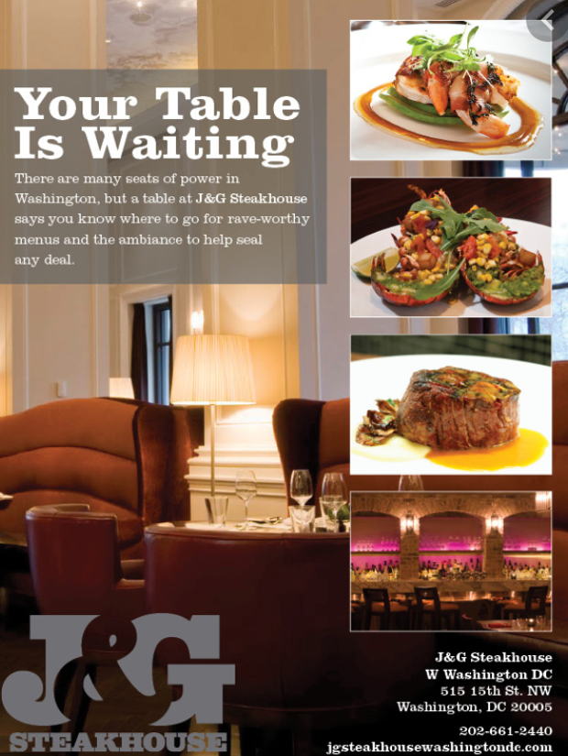

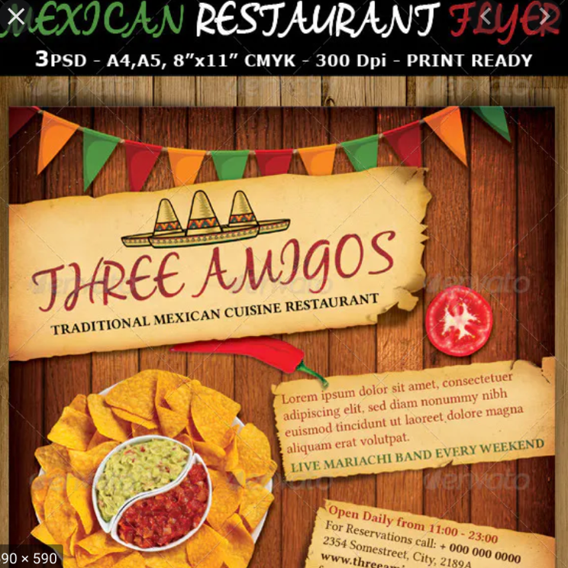
Here are some examples. Use the other side of the page or a plain piece of paper to publish your advert.

