Year 4 Time 03.07.2020 – Problem solving
Remember:

- Underline the key words
- Calculate
- Check you have answered the question
1.
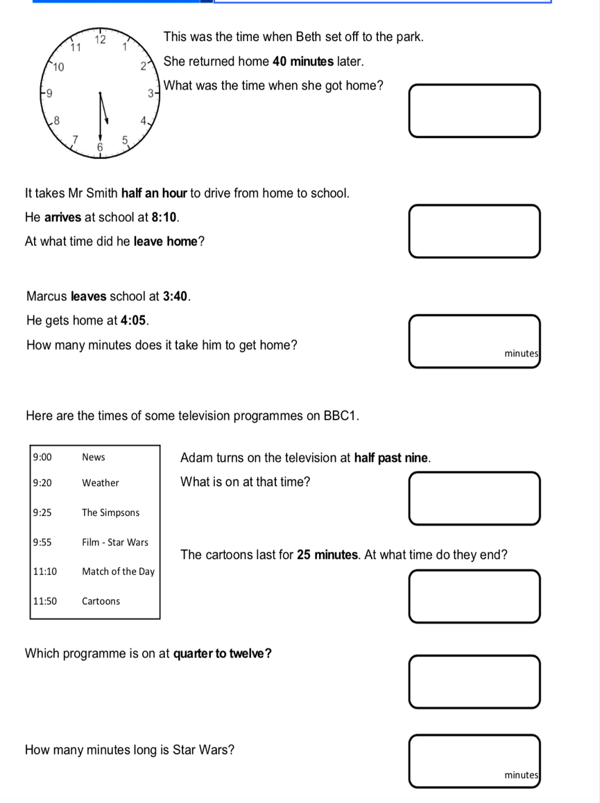

2. 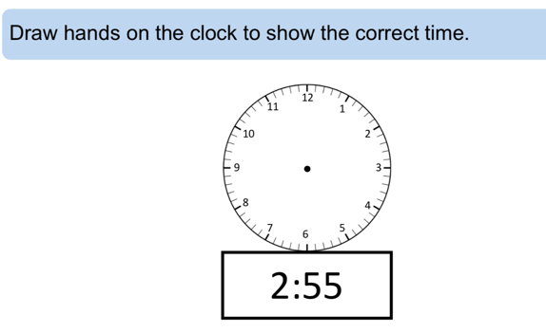

3.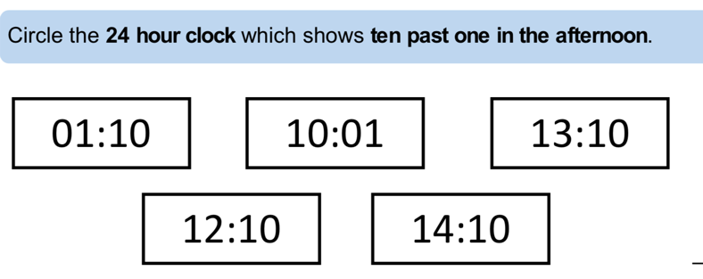

4.
