Year 4 Time 01.07.2020 – Periods of time
Remember:

- Underline the key words
- Calculate
- Check you have answered the question

1.

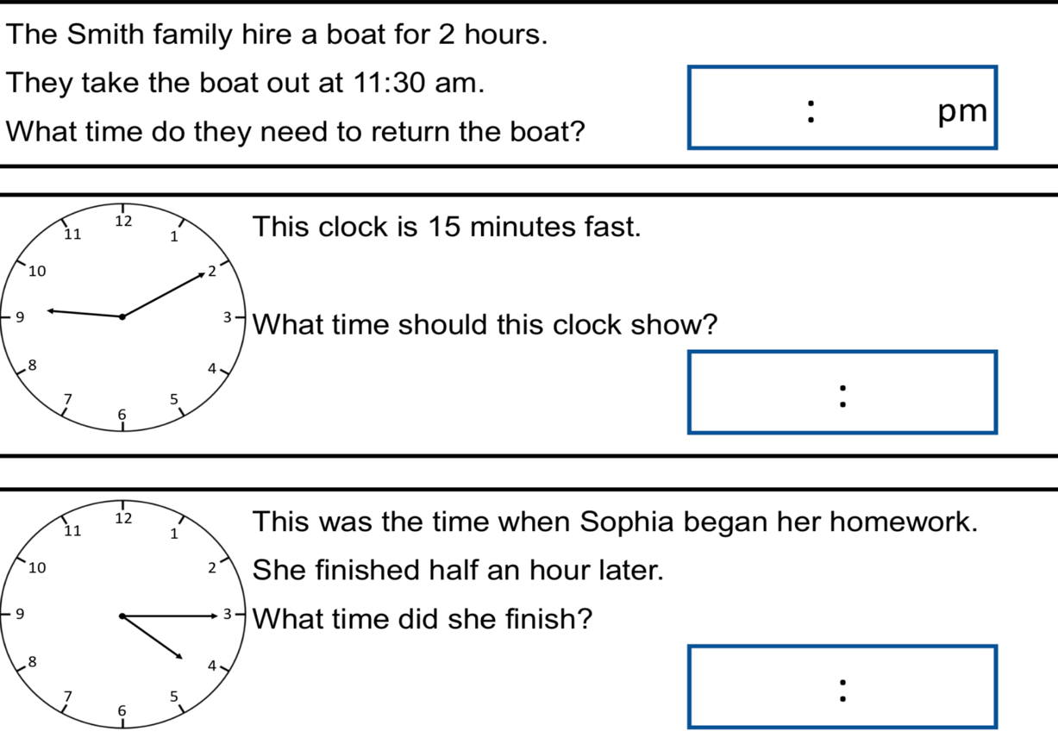

2.

