

Year 3 & Year 4 Writing Week 4

Lesson 4 – Edit and improve

Once you have finished your first draft, go back over you work and make it even better!
- Use a dictionary to check spelling mistakes.
- Check you have used capital letters, full stops, commas after fronted adverbials and in a list correctly.
- Use a thesaurus to improve at least three words.
- Change one sentence.
- Add a fronted adverbial in.
- Add an extra sentence.

Remember its ok for your work to look untidy, it Is a first draft and the best authors are always changing and editing their writing.

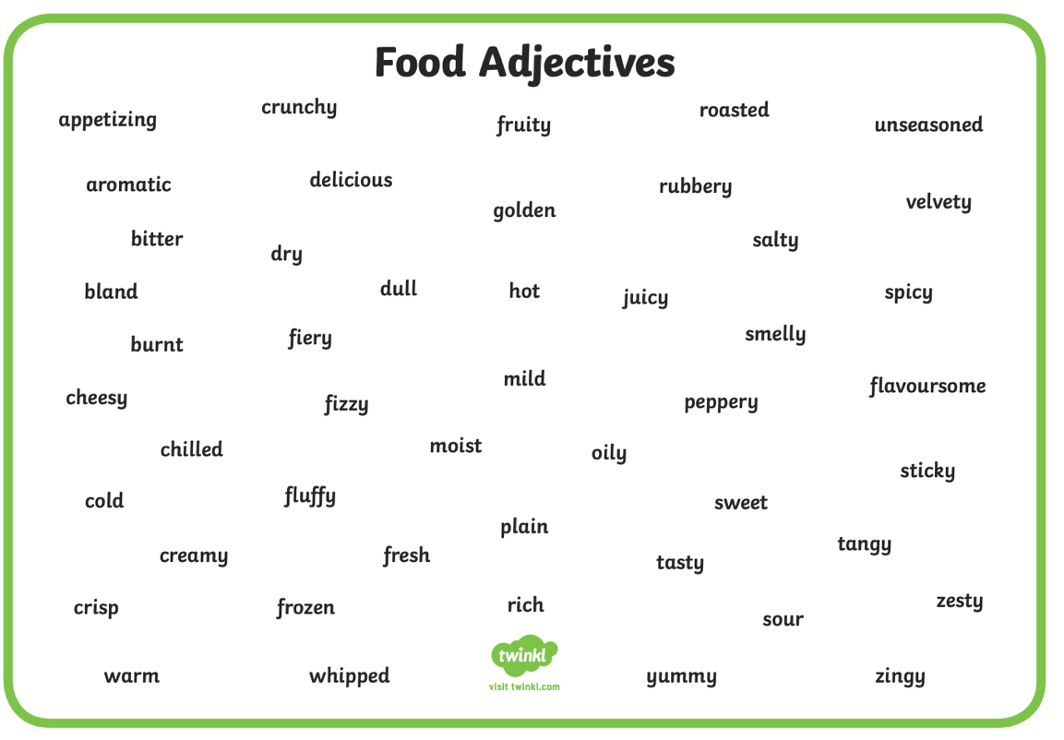
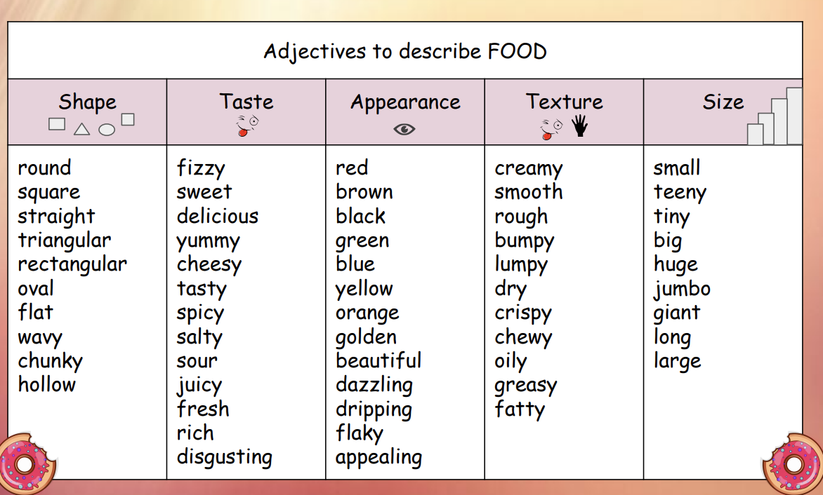
These word banks might help. Remember to only use the positive adjectives, you want people to eat at your restaurant, not scare them off.

