
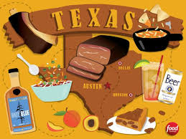
Year 3 & Year 4 Writing Week 4

Lesson 1 – Vocabulary Building

We are heading to Texas which is known for the incredible food, particularly the mouth-watering barbecues! This week we are becoming owners of our very own barbecue restaurant (or vegetarian alternative) and we will be writing our own advert to persuade people to come and eat at our building over all the other competition.

Watch this video of a Texas barbecue restaurant https://www.youtube.com/watch?v=pBCYMD5gezo or https://www.youtube.com/watch?v=JeNbCuhC-oY for a vegetarian alternative to hook you into the week and inspire you.

Tomorrow we will be exploring persuasive features but before we can practise those, we need to build some fantastic, descriptive vocabulary to make our food sound amazing!
Write lots of ambitious vocabulary around the picture below. There is a vegetarian alternative on the other side for those of you who would prefer to advertise a vegetarian restaurant. Use a thesaurus and the internet to explore new, exciting words.

mouth-watering

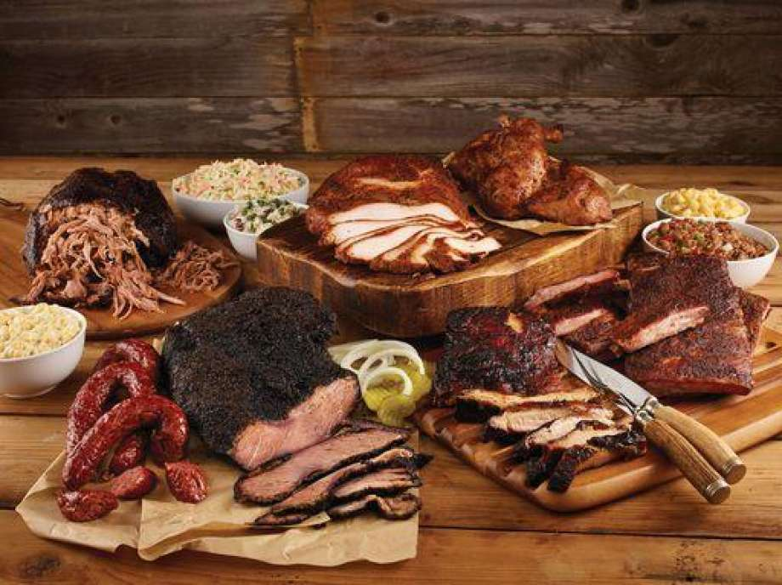

juicy

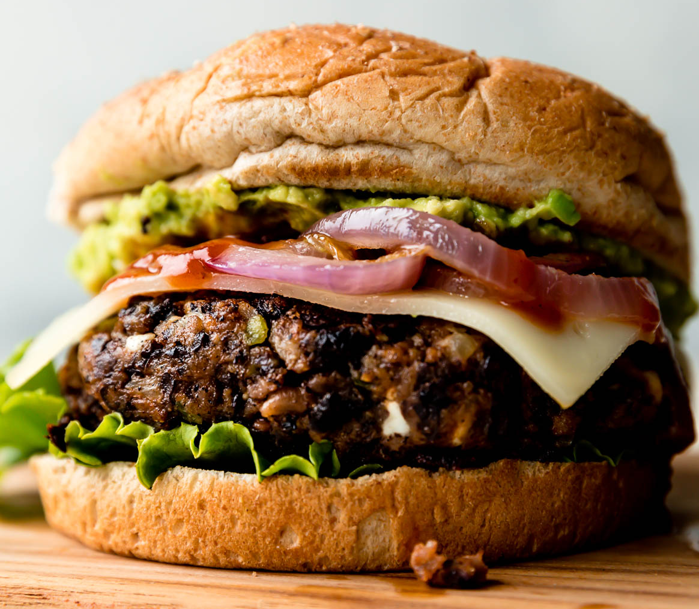
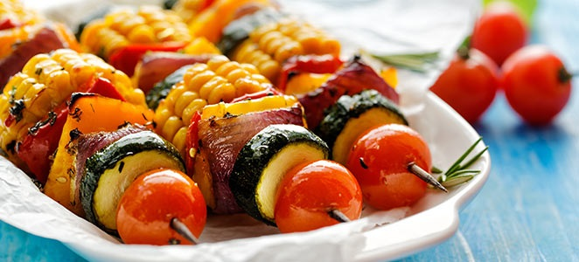
zesty
fresh

