Year 3 Time 03.07.2020 – Time problems

Explain your answers fully – you may need a sentence to explain or some mathematical working out

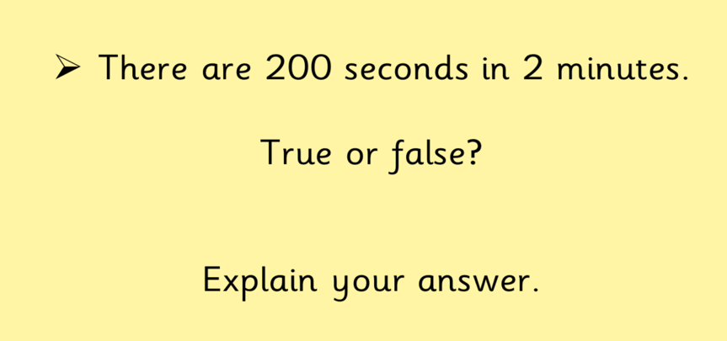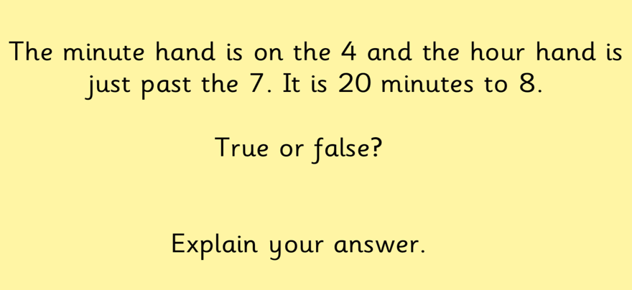

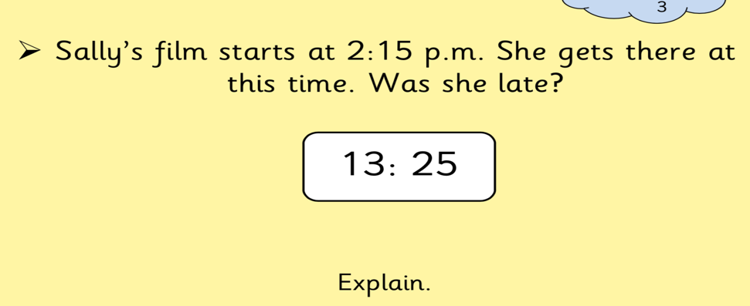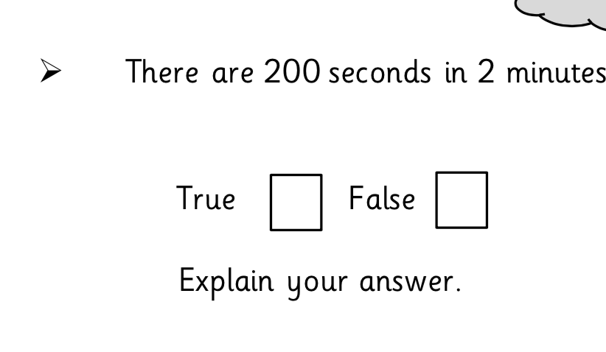

- Tracy goes on holiday to Blackpool for 60 hours. How many full days did she spend on holiday?
- Over two and a half days, Noah spends five hours playing with Anna, he spends 34 hours sleeping and 2 hours doing chores. How much time did he have left for other activities?

