Year 5: 24/6/20 - Read and interpret information in tables
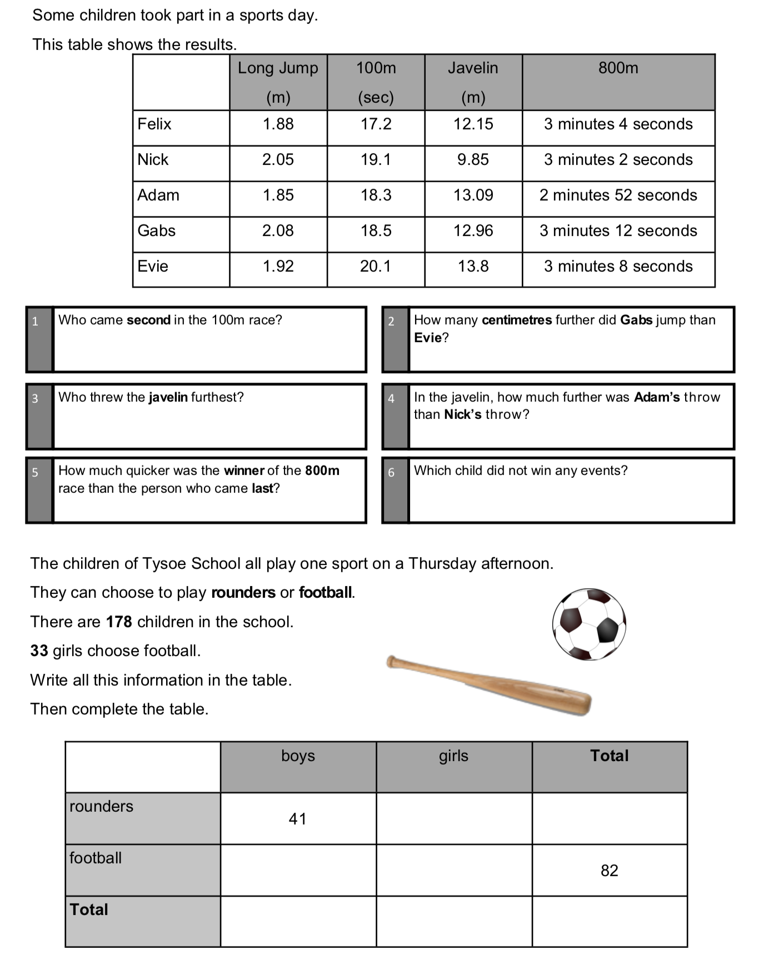

Written Methods Practise

469 x 33 = 3248 ÷ 7 = 234 - 17.38 = 67.5 + 489 =
9567 x 9 = 2109 ÷ 3 = 358.3 - 27.93 = £45.15 - £22.06 =
75 x 78 = 3213 ÷ 9 = 564 - 39.5 = £345.12 - £32.99 =
345 x 45 = 2418 ÷ 12 = 234.5 - 76.7 = 67345 - 23869 =

