Line Graphs Year 5 - 23/6/20

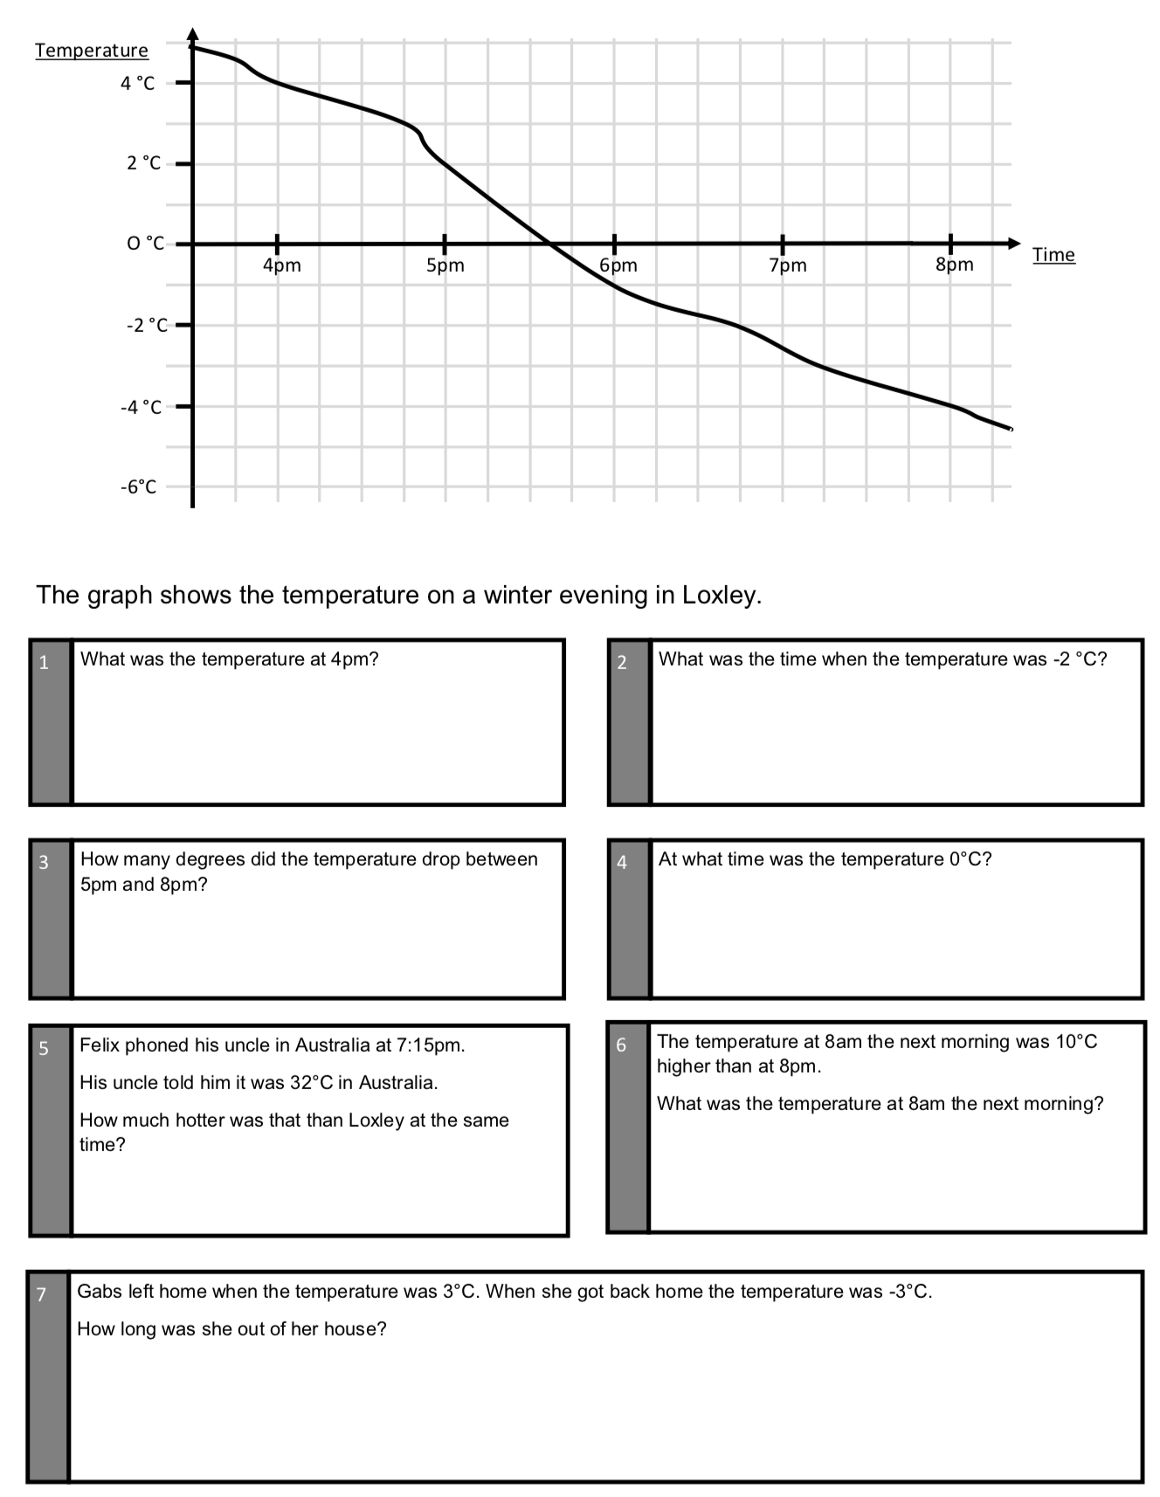

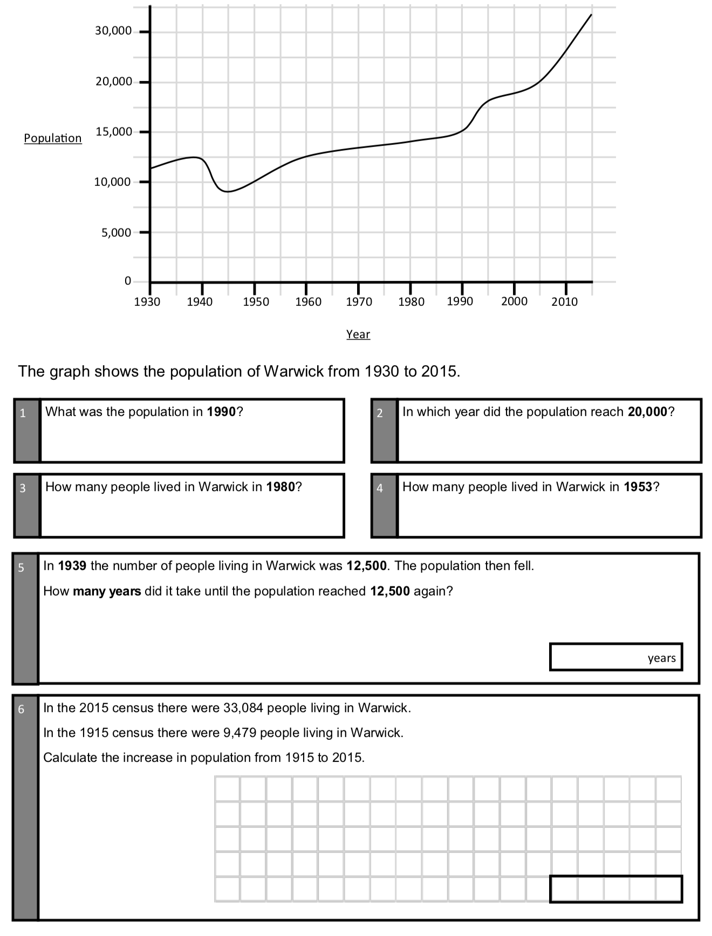

Written Methods Practise

579 x 54 = 4524 ÷ 6 = 23456 - 17385 = 23.4 + 456.08 =
9432 x 7 = 2052 ÷ 8 = 35876 - 27938 = £345.75 - £52.07 =
65 x 48 = 2502 ÷ 3 = 56478 - 39569 = £564.02 - £28.99 =
123 x 34 = 5525 ÷ 13 = 234.56 - 189.2 = 23457 - 19668 =

