Setting Description
Over the next few days, we are going to be exploring a setting in a story and writing our own setting description. The setting in a story is where it takes place.

Activity 1
Read through this setting description. Underline any words you might need to find out the meaning of or words and phrases that you could magpie for your own writing.
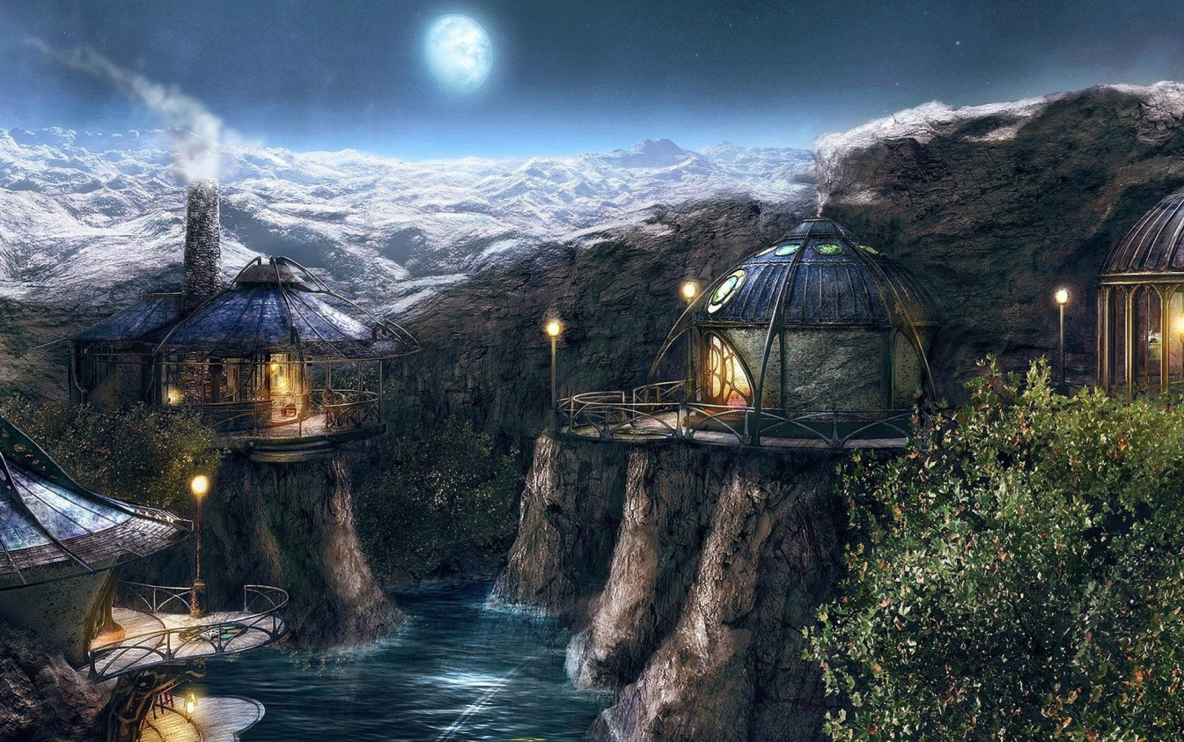

The silvery moon smiled down on the village that night. The wind, for once, ceased its whistling and retired to the distant mountains. Although still flowing, the winding river seemed to have almost stopped - resting, awaiting the coming of the morning. The round houses stood silently in thought, the smoke drifting slowly from their chimneys, indicating that everyone was safely in for the night. The snow that clung to the neighbouring peaks had not yet reached the sleepy hamlet with its icy grip.
Perched on top of the steep yet small cliffs, the huts encircled their inhabitants, hugging them warmly. Lights, inside and out, shone brightly - golden; contrasting with the ghostly orb hanging in the sky. At a glance, a visitor would assume the dwelling places to be built from the same plan, but upon closer inspection each was unique. One had a multitude of emerald eyes, rather like a spider, in its roof, another had a covered veranda and a tall slate chimney stack. Yet another had a lower floor dug out from the sharp slope down to the water, surrounded on one side by a two-tier balcony. All had one thing in common: wooden decorations, intricately carved, forming the framework of each dome-roofed house.
The tranquillity of the scene suggested that all was well in this valley; that the village folk had nothing to fear. Only those who lived there knew of the terrors that the morning would bring. In fact, anyone living this close to the mountain caves knew that all was not as it seemed.

Success Criteria
The key features we can use in a setting description are:
Figurative language:
- Similes (as/like) - emerald eyes, rather like a spider
- Metaphors - heart of stone
- Personification -silver moon smiled down on the village
- Onomatopoeia - swish, crackle
- Alliteration - stood silently

Sensory words/phrases to describe: see, hear, feel, smell, touch/taste - (see) intricately carved wooden decorations - (hear) wind whistling - (feel) warmth of the glowing light - (taste) crisp, winter air - fear - (touch) rippling water
Different sentence openers to hook the reader. Remember fronted adverbials: Where? Perched on top of the steep yet small cliffs, When? On that wintry day, How? Quivering uncontrollably, Ed - Petrified, Connective - Although still flowing, Adverb - Cautiously, Preposition - Under the dark clouds,

Ambitious vocabulary (adverbs -silently powerful verbs - perched, meandered and adjectives - ghostly orb, emerald eyes) to create the atmosphere and mood of the setting - smoke drifting slowly, ghostly orb hanging in the sky

Activity 2: Word and sentence challenges:
- Underline the adverbs in the sentences below?
Confidently, he sauntered through the cold forest. He paused briefly and peered at the white polar bear.

Setting description warm up:

Can you edit and improve this setting description using the success criteria examples above and the image of Hogwarts on the next page? Can you use different sentence openers? Improve and add more ambitious vocabulary? Use sensory words/phrases and include some figurative language?

The path led to a lake. A castle was on a mountain on the other side. The boats went across the lake. Everyone looked at the castle. They moved nearer and nearer to the cliff. The first boat got to the cliff and was taken through an opening in the cliff. They went along a tunnel under the castle.

Activity 3 - Vocabulary Building - To describe a setting you can talk about a few things:
    - What it looks like;
    - What you can see, hear, smell, etc.;
    - How it makes you feel.
Each of these help you create an image for the reader.
Let’s generate some words and phrases to help us with our writing.

What can you see? Hear?
a crooked cloud like a dragon’s talon boat creaking
tremendous turrets

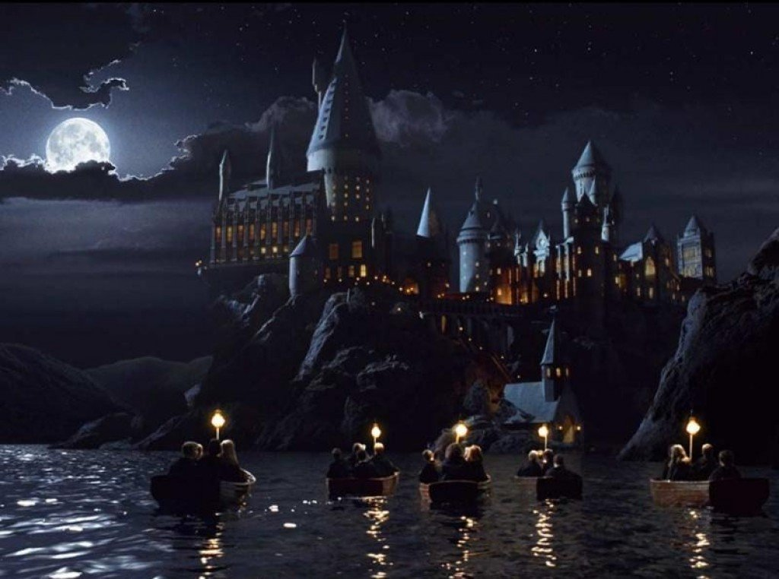

Touch/feel? Smell/Taste?
warm glow of the guiding lamp cold, crisp air
excitement in the air

Activity 4: Now you have generated lots of words and phrases, draft your setting description. Use the model example (from activity 1) and the success criteria to help you. Can you include some figurative language? Once complete, edit your word choices, check your punctuation and add any extra details to create an image for the reader.


Practise your handwriting when publishing!

