Lesson 5
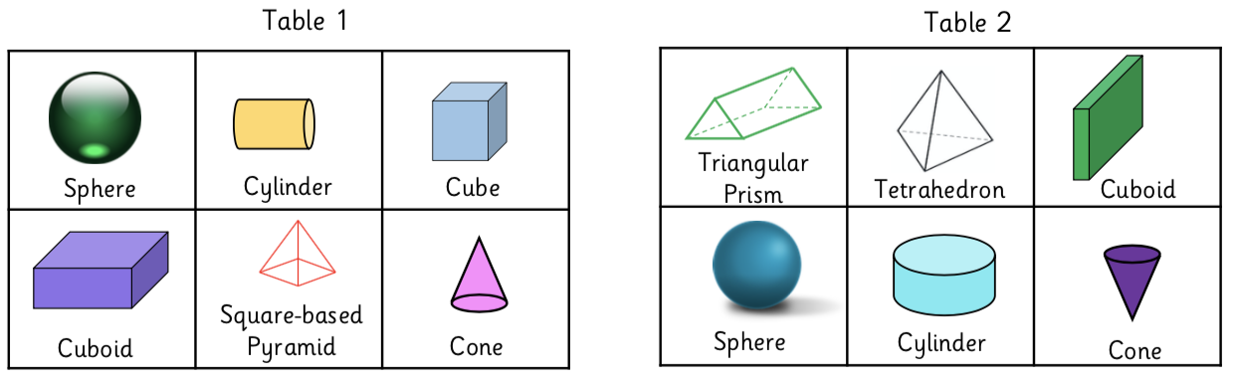
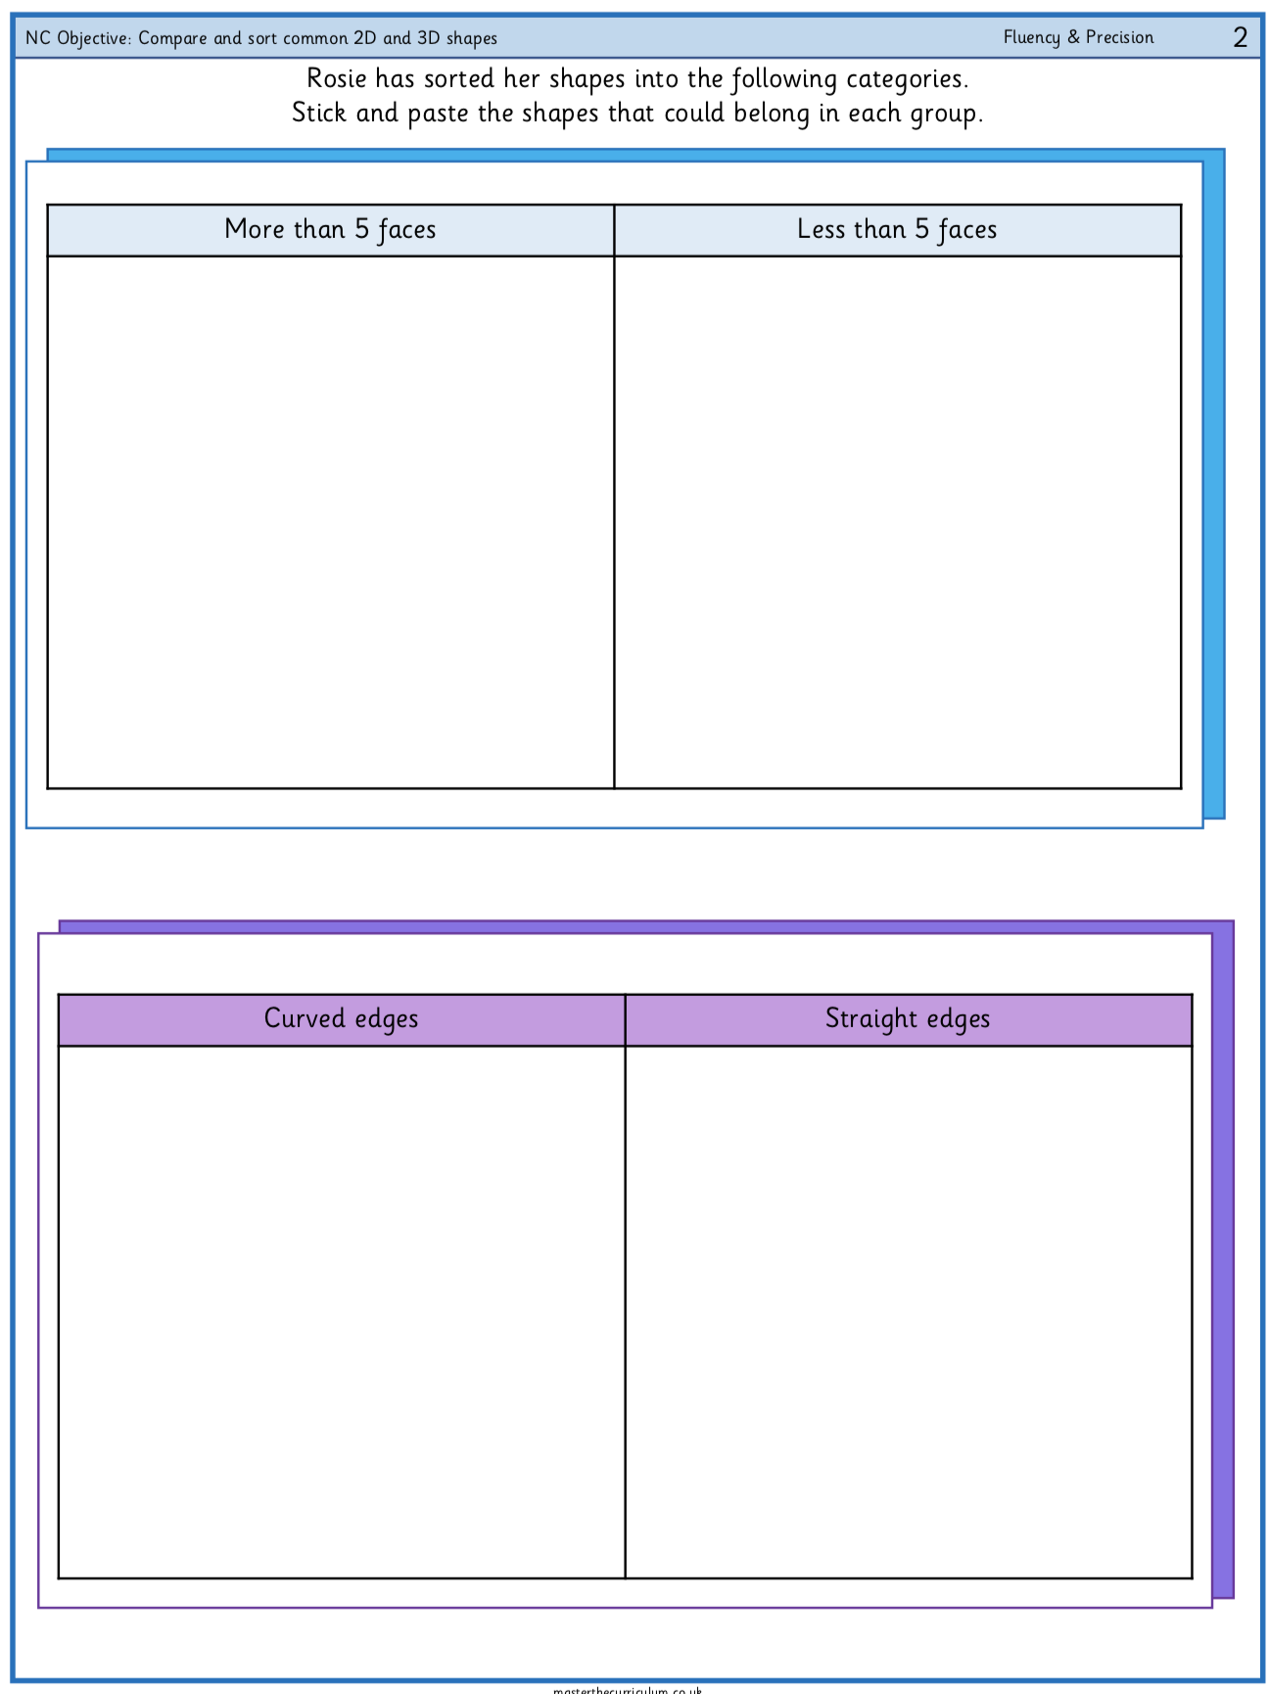
Comparing 2D shapes and 3D shapes

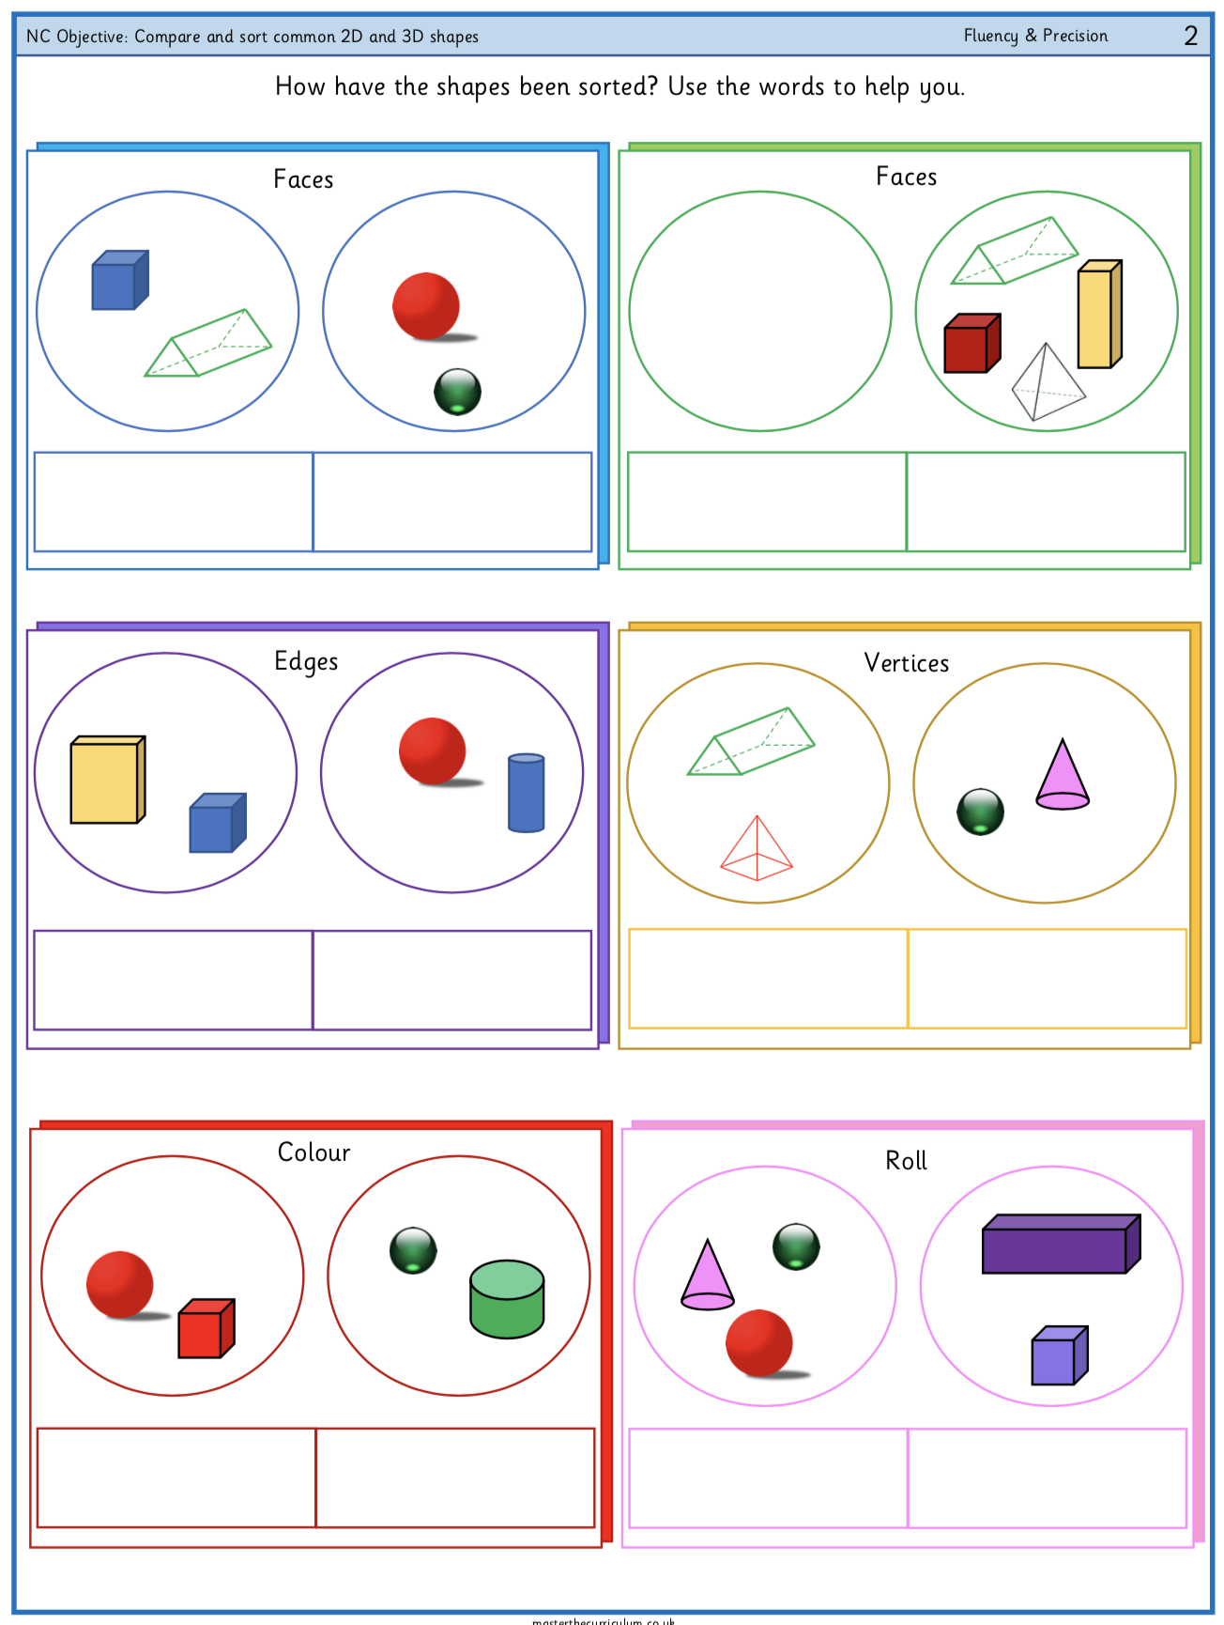
Challenge:

