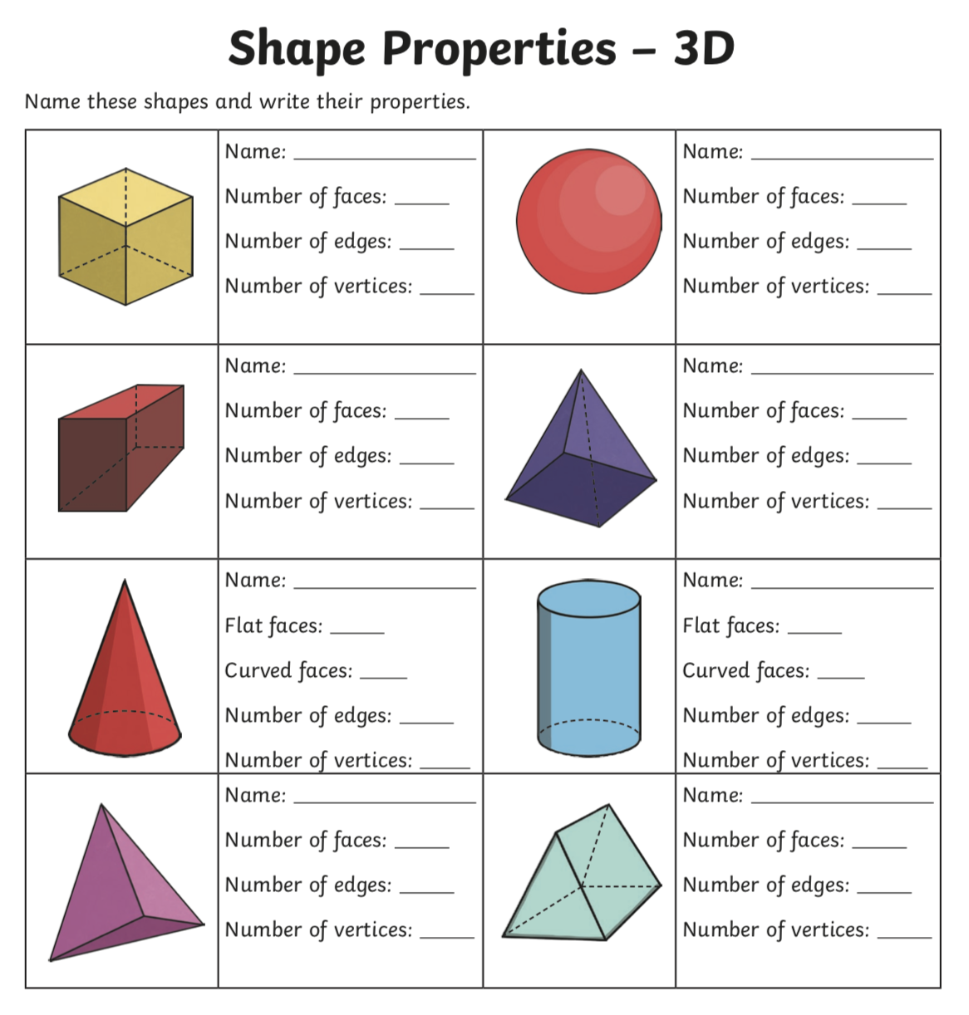
Lesson 3

What 3D shapes can you spot around your home? Name some below:

