Lesson 4
Instructions

Today’s lesson is going to be writing instructions (this may take more than one lesson). Think back on your time during the lockdown. Is there anything exciting that you might have baked, planted, created, etc? Someone else might want to do it too but not know how. You are going to write some step by step instructions on how to do your chosen activity – it might even be instructions on how to create the perfect superhero!

All instructions should contain the following features:
- Title
- Subheading (What you will need)
- List of items
- Subheading (Method)
- Detailed steps to create your finished product.

Don’t forget your time connectives to start your sentences (first, next, then, after that, finally). You could even attach/draw pictures to go with each instruction if you wish.

There is an example of instructions on the next page that you may even want to have a go at yourself!

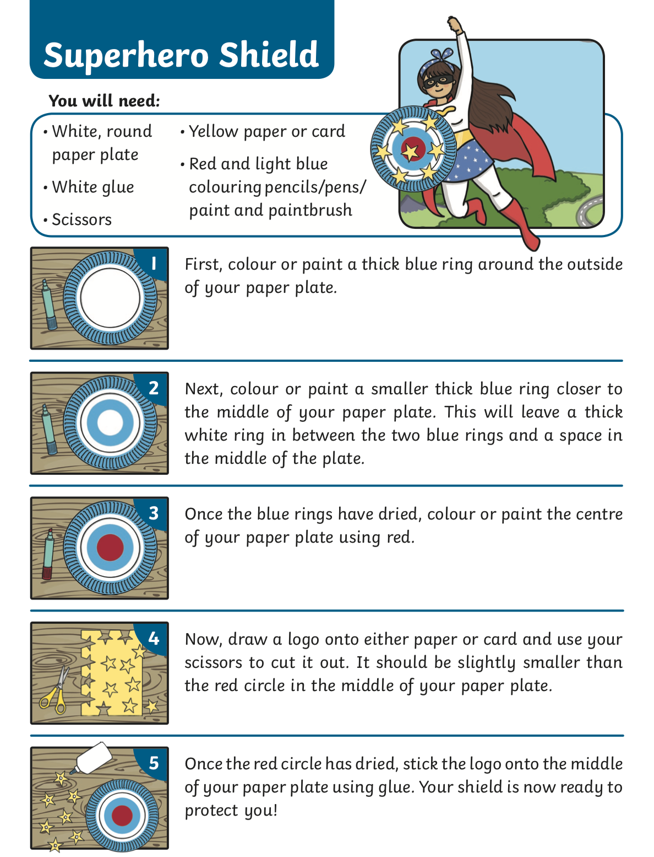
Example Instructions:

