Lesson 3
Creative writing

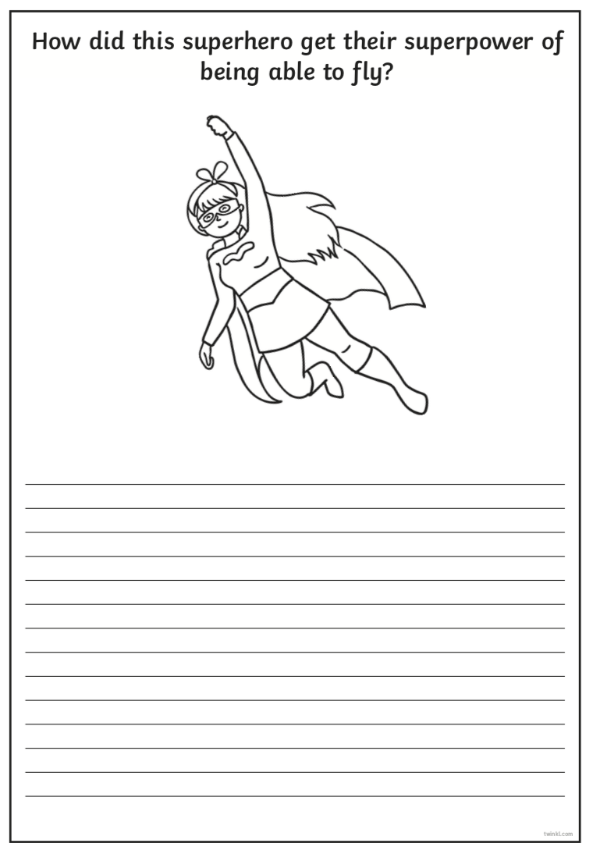
Use the writing prompt below to think of an answer to the question. Use your imagination the best you can when answering. Use your bingo board to help you extend your sentences.

