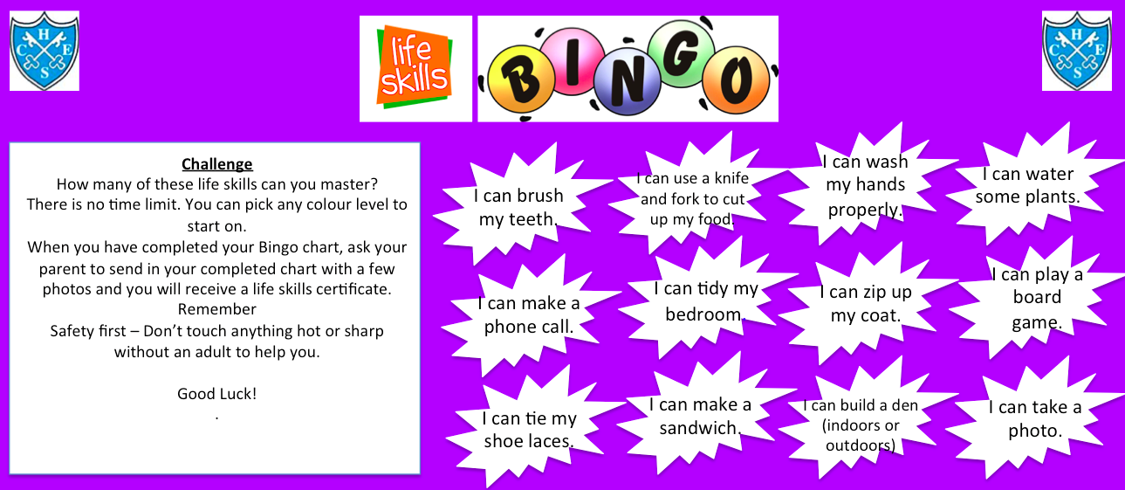

Level 1 - MY PHOTOS – Name : ..................................Class: .......................

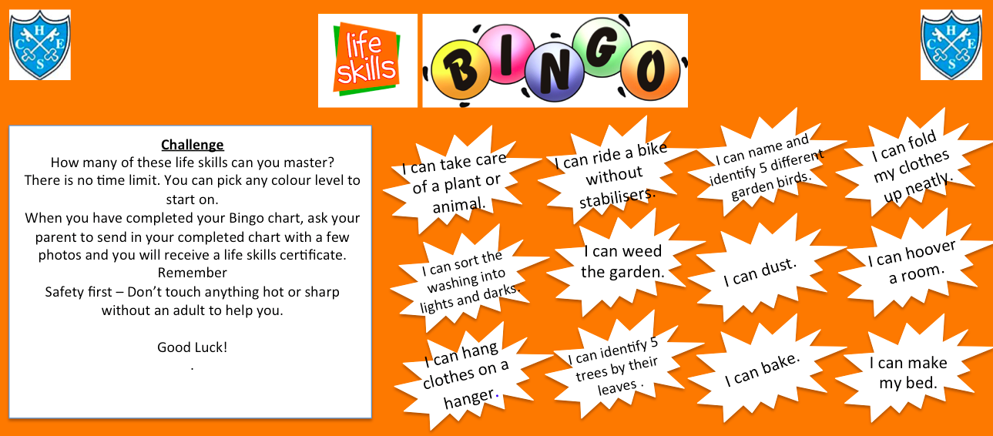

Level 2 - MY PHOTOS – Name: ..................................Class..........

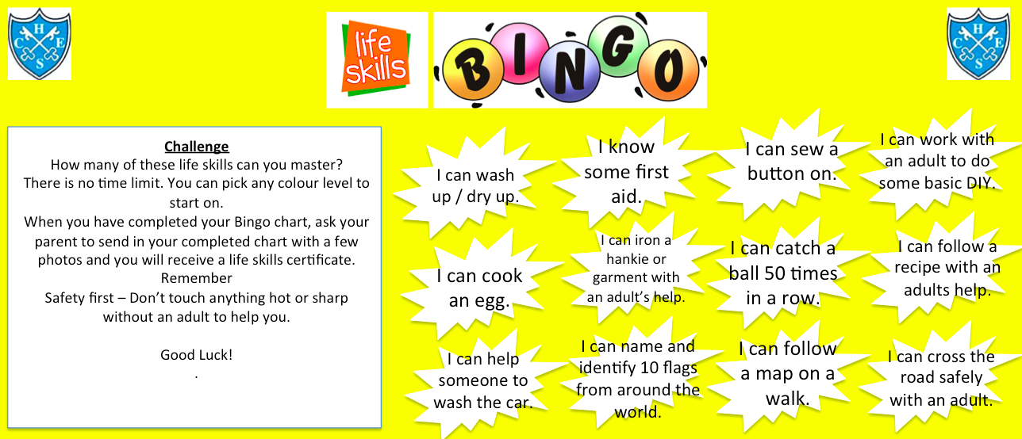

Level 3 - MY PHOTOS – Name : ..................................Class: .......................

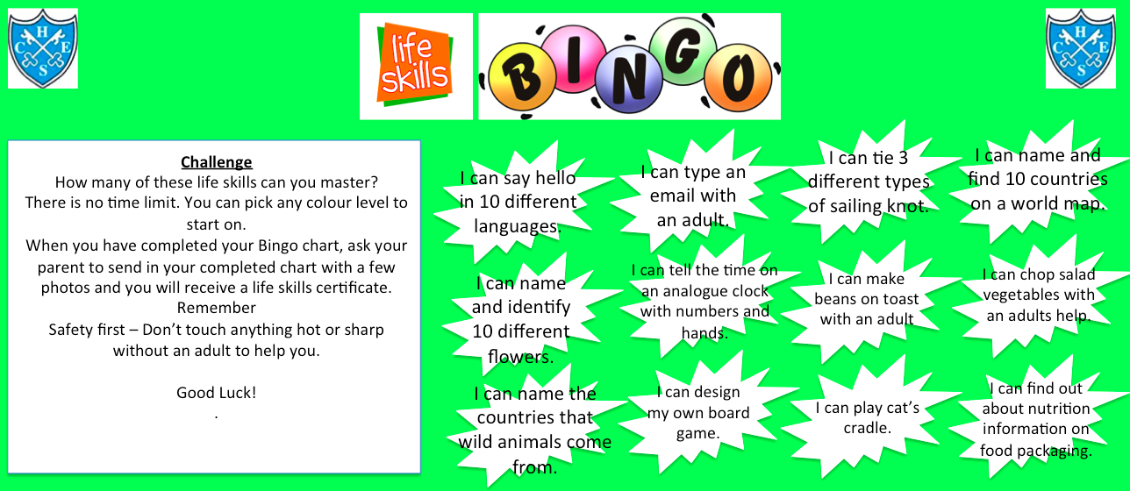

Level 4 - MY PHOTOS – Name : ..................................Class: .......................

