Lesson 3 and 4
Story Opening

Using your comic strip to help you, see if you can create a story opening for your superhero and villain.

The objective is to make the reader want to keep reading

Make it dramatic, informative or exciting using some of the components discussed.

- Describing a character
- Describing a setting
- Start with an action
- Use some dialogue

Setting:
Could you give the reader information about the setting :–
Where and when is it based? What time of year (or season)
What can you see, hear, smell or touch?
What would the audience see if they were standing there?

Character:
Could you introduce a character (or more than one)? Tell the audience about character, their name, something about them that is relevant to the story.
Could you tell us about their past, something interesting that will be impact on what happens? Or something that will explain why something will happen?

Action
Could you start the story with an interesting action that sets up something that will happen?

Dialogue

Could you show us a conversation that a character may have that tells us a little about what might happen? Or something that suggests a possible storyline, or leaves the reader with a question?

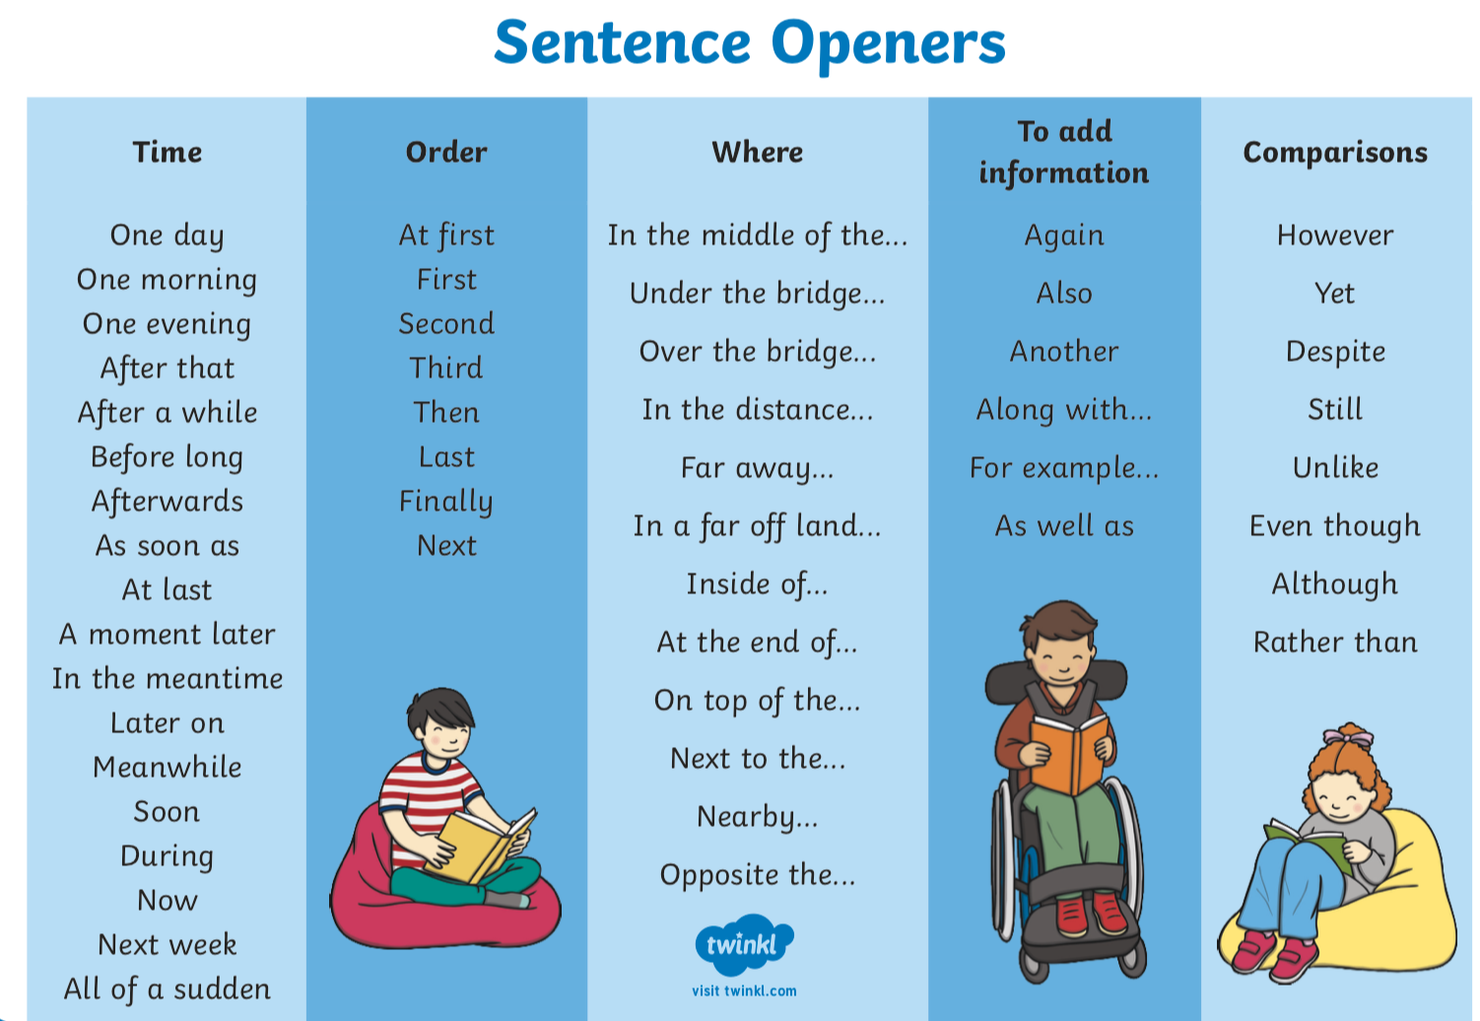
These sentence starters may help you.

