Lesson 2
Comic Strip

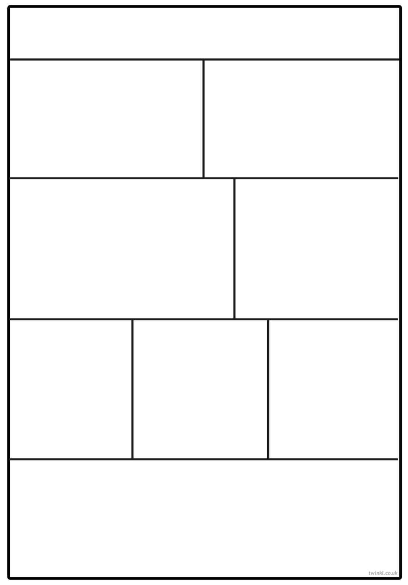
Now you have created your own superhero it is time to put it into ACTION! If you can, look at comic strips that have been created and look at the features, such as lots of pictures, small bursts of speech etc. Can you create a comic strip based on your superhero and the villain?
