Lesson 1
Wanted Poster

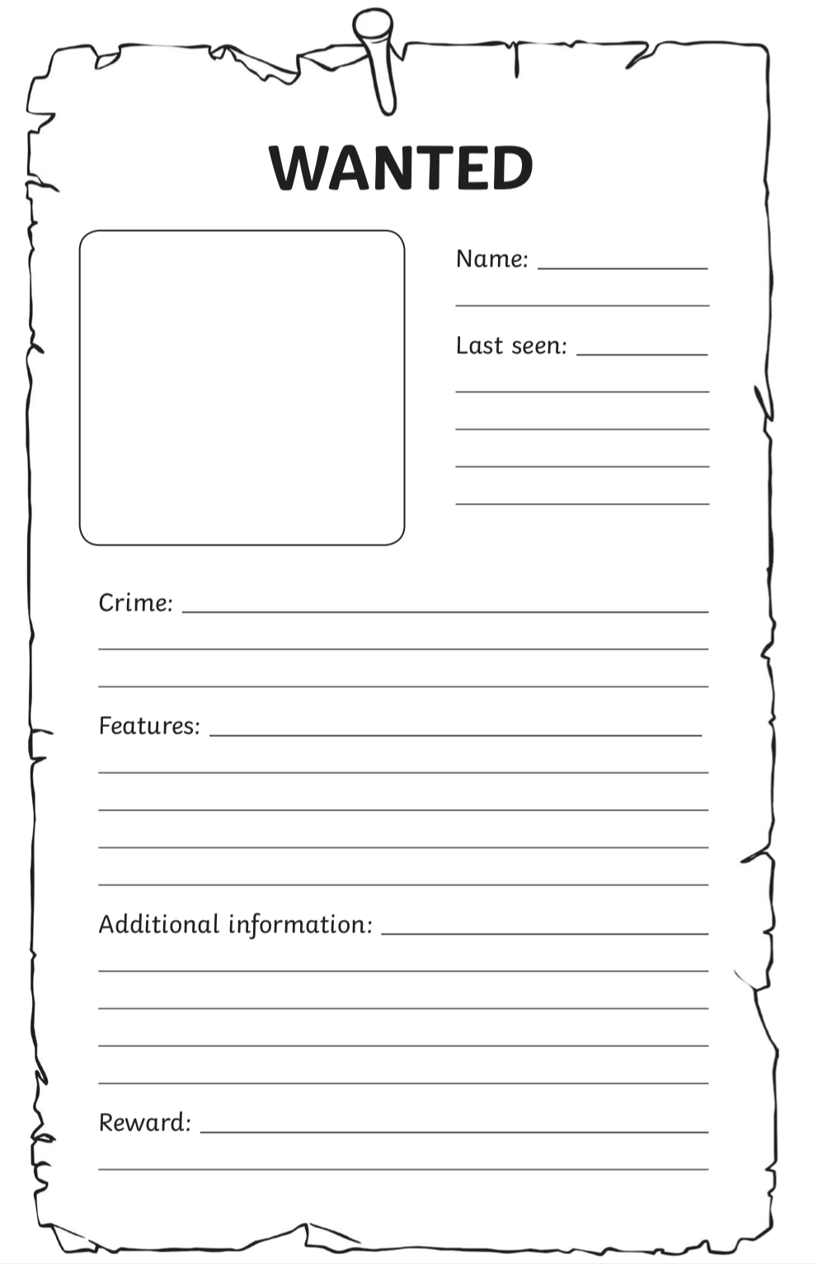
You have created a new superhero, but now is the time to create their enemy! Draw a picture of a villain for your superhero and describe it using the wanted poster below. Be as creative as possible!

