Lesson 4
Fractions of shapes

Today we are looking at fractions of shapes. Colour the amount of the shape asked. Can you also write the fraction as a number underneath the words? For example: one half = ½

Questions

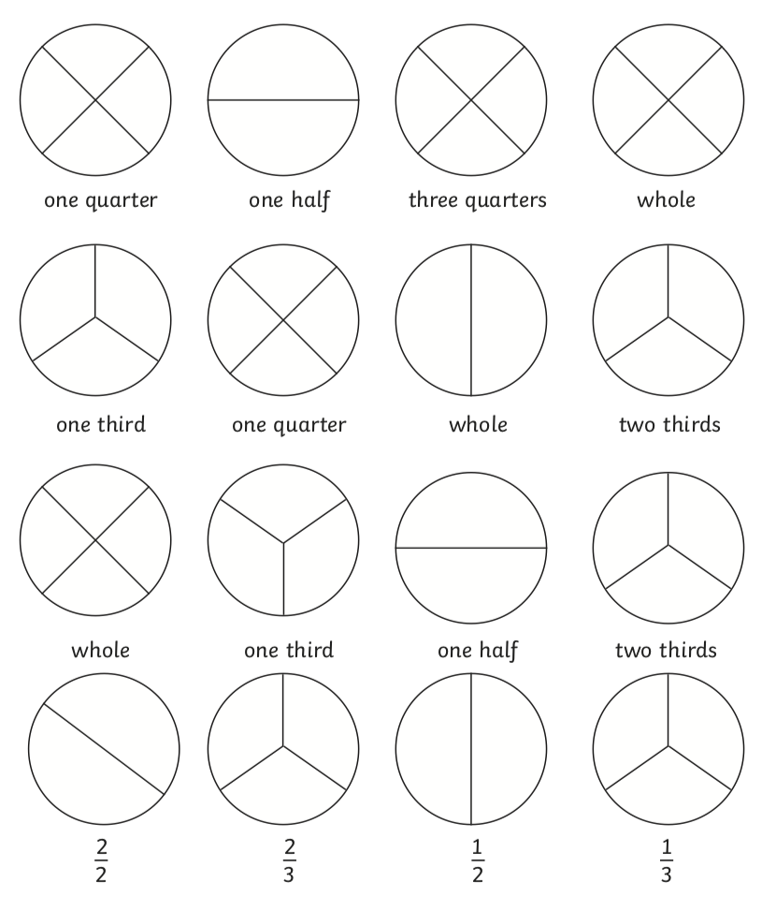

Reasoning

