Lesson 2
Multiplication

In today’s lesson we are focusing on multiplication. You can continue using Hit the Button and Times Tables Rockstars to test your child’s recall skills daily.

It is important to also put multiplication into context. The worksheet has some calculations with space for your child to work out the answers and some reasoning questions based on multiplication.

Questions

6 x 5 =

4 x 10 =

12 x 2 =

4 x 3 =

11 x 5 =

7 x 10 =

8 x 2 =

9 x 3=

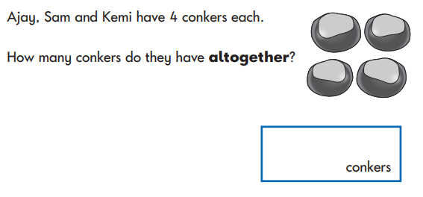
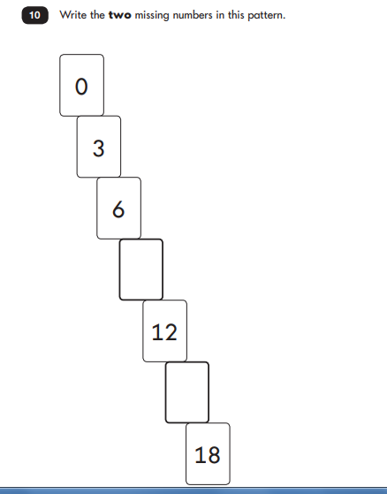
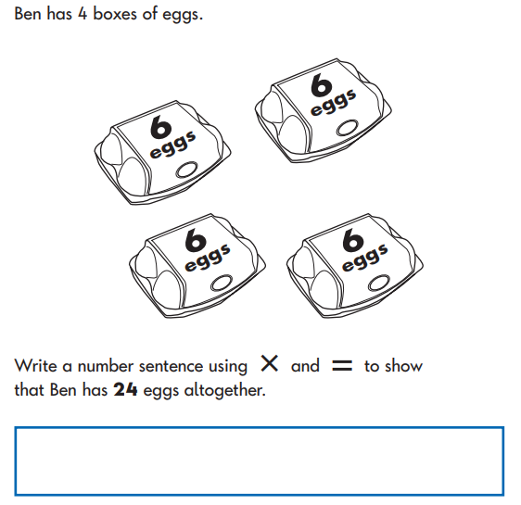
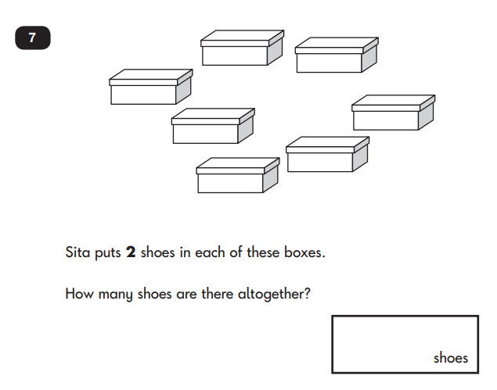
Reasoning

