1. Calculate the area of a square with sides measuring 8cm. | 2. 7.9 ÷ 100 =
3. 6980 + 74.04 = | - ⅞ + ⅔ =
5. Add together the number of faces of a triangular prism, the number of degrees in a right angle and the number of minutes in an hour. | 6. 345 x 81 =

Maths 2

Speedy Six
Fractions

⅔ x ⅗ = | ⅝ ÷ ⅓ =
⅞ + ½ = | ⅚ - ⅖ =
⅘ ÷ 3 = | ⅘ + ¾ =

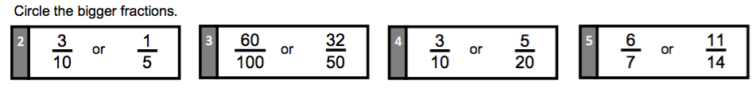
Fractions
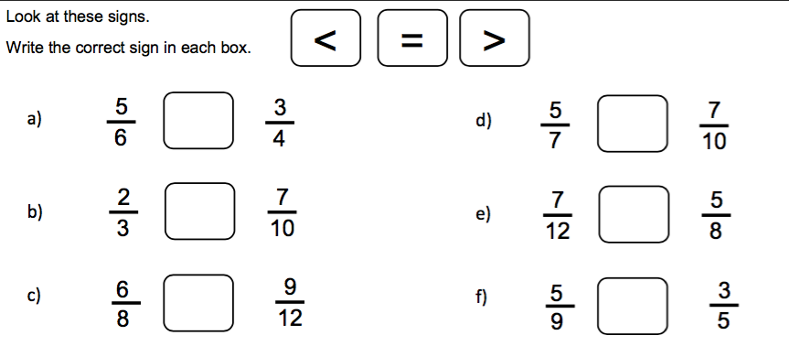
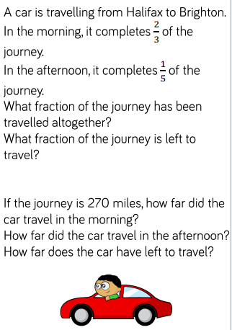
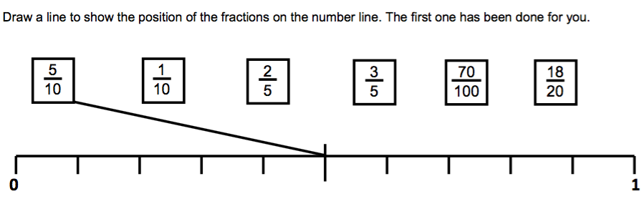
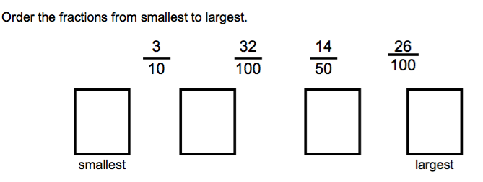

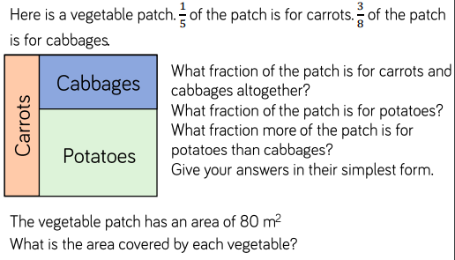

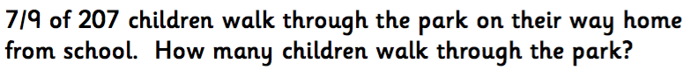
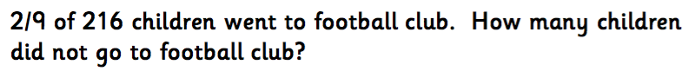

Top Tip: When adding and subtracting fractions to solve problems, start by making the denominators the same.

