Persuasive Writing

Over the next few days, we are going to create a state-of-the-art gadget for a spy, or one for school, or even one to use around your house.
We are going to be persuading our reader to buy one.

Activity 1

Read through the model example. Underline any words you might need to find out the meaning of or words you could magpie for your own writing.
Multifunction Mobile Phone
Are you about to embark on your first mission as a spy? If so, you will need a state-of-the-art, Multifunction Mobile Phone, that very few have the skills to own. Don’t be the only spy on the block left wondering how to phone home!
The Multifunction Mobile Phone is the ideal device for all top spy agents on all of the most important, international and intergalactic missions. The must-have gadget boasts a host of amazing features. You will have 24 hour, worldwide access to the phone so that you can always be in contact with those back home. It will provide you with the ability to make untraceable calls, perfect for any undercover mission. If those features were not enough, the handset is manufactured out of robust titanium steel so that it functions underwater and in the depths of outer space.
Additionally, this ideal mobile phone has the added bonus of a hidden tranquillizer dart that can be fired through the aerial. Guaranteed to leave your enemies stunned (though with no serious after effects). Perhaps the most essential reason for purchasing this ‘must have’ phone is that it can only be accessed by the owner. Modern fingerprint and facial recognition (FFR) technology make this the ultimate choice for spies.
Don’t just take my word for it! This phone is recommended by top super spy, Alex Rider and comes complete with charger, free leather case and technology that, before now, money couldn’t buy. Order now from spygadgetzone.com

Success Criteria

Key features of a persuasive piece of writing are:
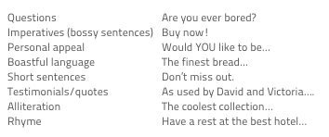

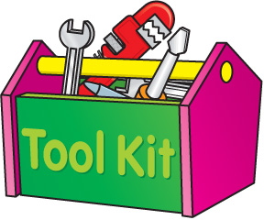

Can you find any of the success criteria in the model example?
- Underline or circle examples in the text.

Persuasive Warm-Up

- Choose one or two of the following scenarios, and write a short, persuasive speech to persuade…

• a snowman to come into the kitchen;
• a fly to make friends with a spider;
• Cinderella not to go to the ball;
• a parent to let you play out late;
• a teacher to let you stop work early and have extra break!



Activity 2

Your own gadget design.
Your first job is to think about the function. Will it be for your house (bedroom tidier, homework completer, personal assistant), for a spy (watch, car, pen) or something else inventive that would be a useful gadget?

- Draw your design.
- Name your gadget.
- Label it’s features.
- Who would the gadget be useful for?

Example:

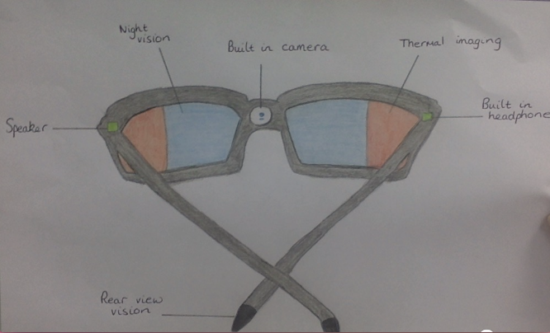

Design

Activity 3:
Draft your persuasive advert (on draft paper) to sell your new gadget.
Think about using a similar structure to the model example (opening hook, main features, extra features, key reason for purchase including a recommendation/quote).
Once complete, edit your word choices, check your punctuation and add any extra details to persuade the reader.
Practise your handwriting when publishing!

Success criteria | Self assessment
I have included a hook or a promise. E.g. You won’t be able to live without...
I have used superlatives/exaggeration. E.g. good=best.
I have spoken to the reader (YOU could own…
I have used a rhetorical question. E.g. Wouldn’t you love to...?
I have used bossy/ imperative verbs and strong adverbs.
I have used positive adjectives and feelings, ignoring the negatives.
I have given important product information.
I have included a catchy slogan or catch phrase, using alliteration, similes, metaphors or rhyming.
I have used eye catching, memorable pictures.

Slogan

Image

