Year 4 Parallel and Perpendicular
Horizontal and Vertical
Parallel and Perpendicular
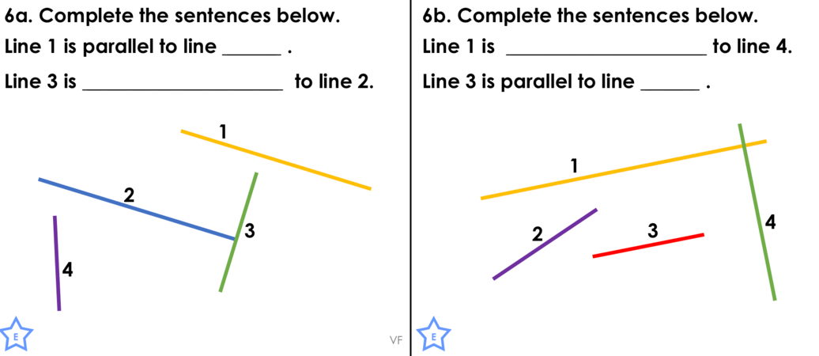

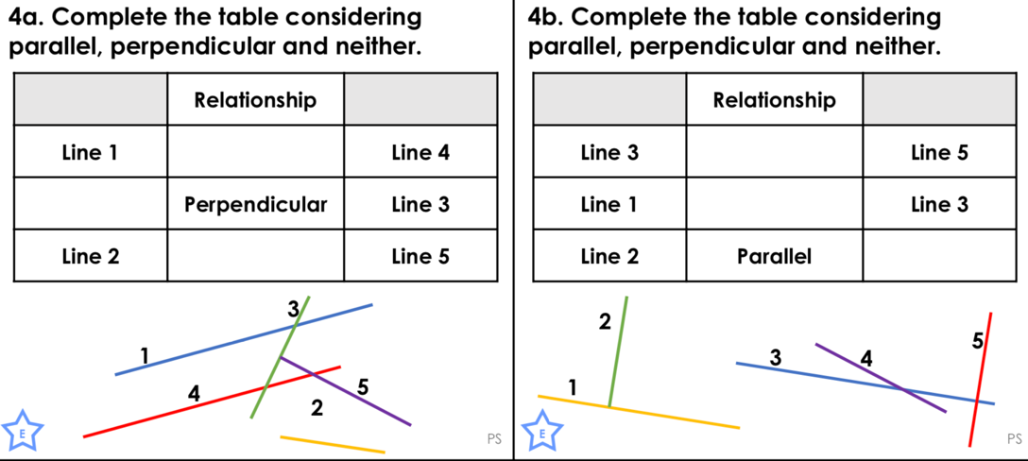

Horizontal and Vertical
