Year 3 – Horizontal, Vertical, Perpendicular, and Parallel Lines

Horizontal and Vertical Lines
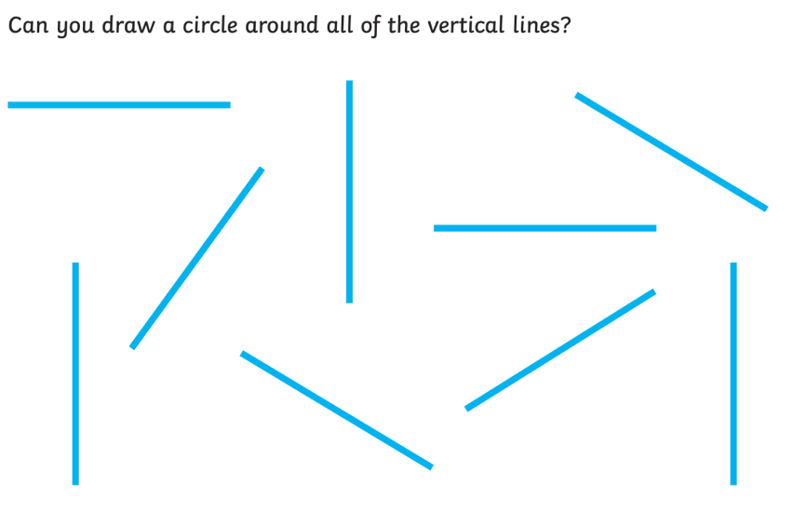
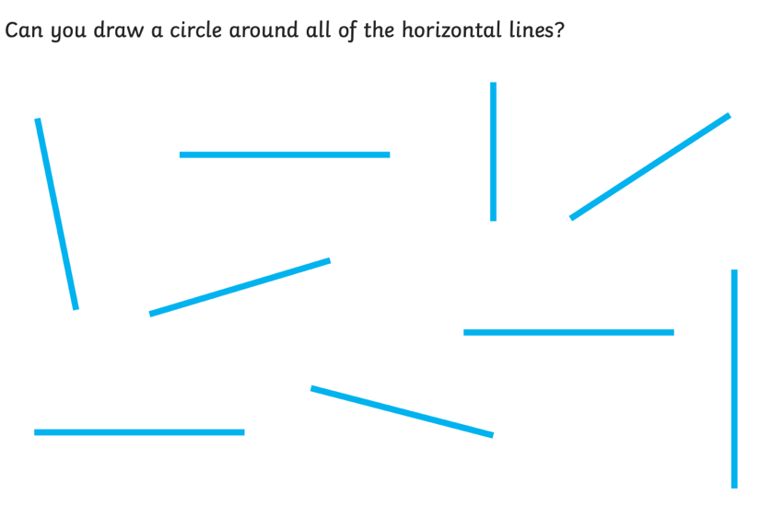

Parallel and Perpendicular Lines
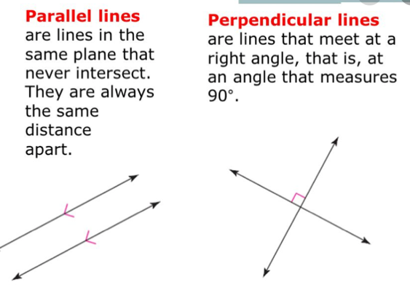

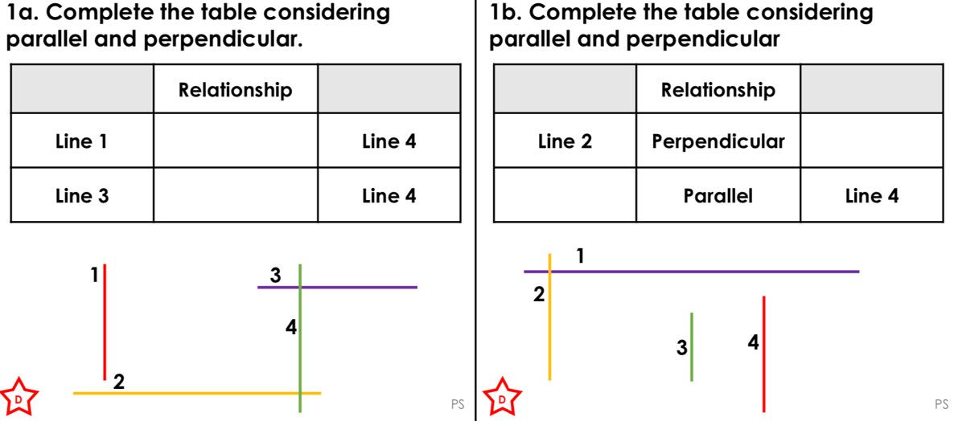
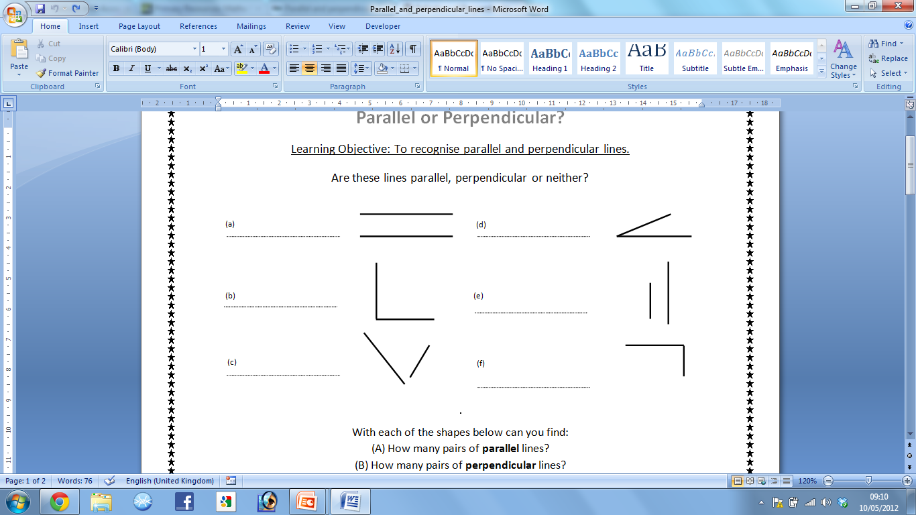
Are these lines parallel, perpendicular or neither?

