Year 3 – Horizontal, Vertical, Perpendicular, and Parallel Lines

Regular shape – all sides are equal and all inside angles are equal.
Irregular shape – does not have equal sides or equal angles

2D

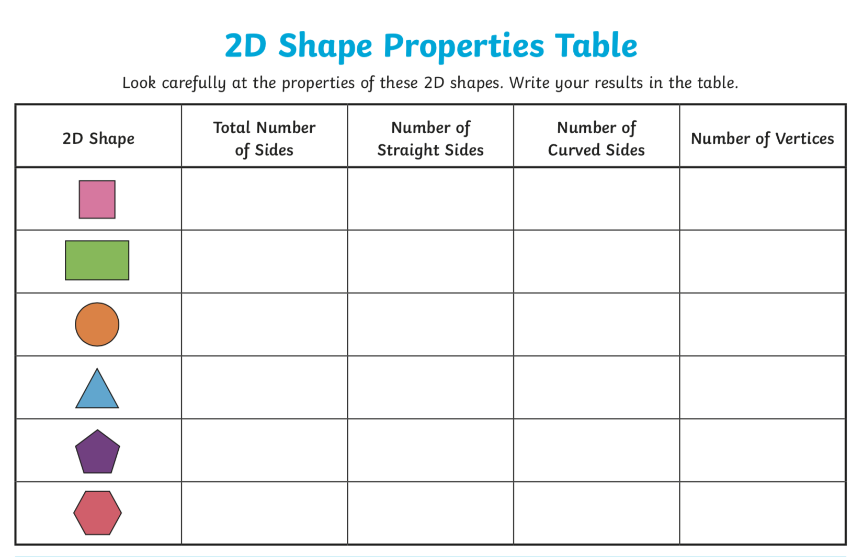

Can you use a ruler and draw a regular triangle with 5cm sides, a square with 7cm sides?
Can you use a ruler to draw an irregular pentagon and hexagon?

3D

